|  |
| --- |
| k8s备课 |
| **作者：老男孩Linux教育-张亚**  **归档：上课文档**  **2019/11/16** |
| **快捷键：**  Ctrl + 1 标题1  Ctrl + 2 标题2  Ctrl + 3 标题3  Ctrl + 4 实例  Ctrl + 5 程序代码  Ctrl + 6 正文 |
| **格式说明：**  蓝色字体：注释  黄色背景：重要  绿色背景：注意 |

目 录

第1章 使用docker的优点与缺点 1

1.1 好处 1

1.2 缺点 2

1.3 编排工具 3

第2章 k8s介绍 3

2.1 概述 3

2.2 优势 4

2.3 基本概念 5

2.4 Pod 5

2.5 Name/Namespace 6

2.6 Label/Label选择器 6

2.7 Service/Ingress 7

第3章 核心组件介绍 7

3.1 apiserver 7

3.2 controller-manager 8

3.3 scheduler 8

3.4 kubelet 9

3.5 kube-proxy 9

3.6 k8s三条网络 10

3.7 逻辑架构 10

3.8 知识梳理 11

第4章 实验环境 11

4.1 实验架构图 11

4.2 安装部署方式 12

第5章 虚拟机准备环境 12

5.1 实验环境准备介绍 12

5.2 实验环境检查 12

5.3 配置yum源和epel源 13

5.4 安装必备工具 13

5.5 配置时间同步 13

5.6 升级内核 13

第6章 DNS服务配置 13

6.1 安装bind9 13

6.2 修改配置文件 13

6.3 配置区域文件 14

6.4 编辑区域主机数据文件 14

6.5 配置业务域数据文件 15

检查语法 15

6.6 启动服务 15

6.7 检查服务是否正常解析 15

6.8 修改客户端使用DNS服务 15

6.9 检查并测试 16

6.10 修改其他主机 16

6.11 配置DNS客户端 16

6.12 windows修改网卡DNS 17

第7章 准备签发证书环境 18

7.1 安装CFSSL 18

7.2 创建生成CA证书签名请求（csr）的JSON配置文件 18

7.3 生成CA证书和私钥 19

第8章 部署docker环境 20

8.1 安装 20

8.2 配置 20

8.3 启动 20

8.4 检查 20

第9章 部署docker镜像私有仓库harbor 21

9.1 下载harbor离线安装包并解压 21

9.2 配置 21

9.3 安装 21

9.4 配置Nginx代理 21

9.4.1 配置源 21

9.4.2 安装Nginx 22

9.4.3 配置子配置文件 22

9.4.4 启动Nginx 22

9.5 配置DNS解析harbor地址 22

9.5.1 修改配置文件 23

9.5.2 重启服务 23

9.5.3 测试解析 23

9.6 浏览器访问新建仓库 24

9.7 拉取镜像改名上传到harbor 24

第10章 部署Master节点服务 24

10.1 部署etcd集群 24

10.1.1 集群规划 25

10.1.2 创建基于根证书的config配置文件 25

10.1.3 创建生成自签证书签名请求(csr)的json配置文件 26

10.1.4 生成etcd证书和私钥 27

10.1.5 检查生成的证书和私钥 27

10.1.6 创建etcd用户 27

10.1.7 下载软件，解压，创建软连接 27

10.1.8 创建目录，拷贝证书，私钥 27

10.1.9 创建etcd服务启动脚本 28

10.1.10 调整权限 28

10.1.11 安装supervisor软件 29

10.1.12 创建etcd-server的启动配置 29

10.1.13 启动etcd服务并检查 29

10.1.14 安装部署启动检查所有集群 29

10.1.15 检查集群状态 33

10.2 部署kube-apiserver集群 33

10.2.1 集群规划 33

10.2.2 下载软件，解压，创建软链接 34

10.2.3 签发client证书 34

10.2.4 签发kube-apiserver证书 35

10.2.5 拷贝证书至各运算节点，并创建 36

10.2.6 创建配置 36

10.2.7 创建启动脚本 38

10.2.8 调整权限和目录 39

10.2.9 创建supervisor配置 39

10.2.10 启动服务并检查 40

10.2.11 安装部署启动检查所有集群 40

10.2.12 配置4层反向代理 40

10.2.13 配置keepalived 41

10.2.14 启动代理并检查 43

10.3 部署controller-manager 44

10.3.1 集群规划 44

10.3.2 创建启动脚本 44

10.3.3 调整权限 44

10.3.4 创建supervisor配置 44

10.3.5 启动服务并检查 45

10.3.6 22服务器操作 46

10.4 部署kube-scheuler 46

10.4.1 集群规划 46

10.4.2 创建启动脚本 46

10.4.3 调整文件权限，创建目录 46

10.4.4 创建supervisor配置 46

10.4.5 启动服务并检查 47

10.4.6 22服务器操作 48

10.5 检查主控节点 48

第11章 部署Node节点服务 49

11.1 部署kubelet 49

11.1.1 集群规划 49

11.1.2 签发kubelet证书 49

11.1.3 拷贝证书到各运算节点 50

11.1.4 创建配置 50

11.1.5 准备pause基础镜像 52

11.1.6 创建kubelet启动脚本 52

11.1.7 检查配置，权限，创建日志目录 53

11.1.8 创建supervisro配置 53

11.1.9 启动服务并检查 53

11.1.10 检查运算节点 54

11.1.11 安装部署启动检查所有集群规划 54

11.2 部署kube-proxy 54

11.2.1 集群规划 54

11.2.2 签发kube-proxy证书 54

11.2.3 拷贝证书至各个运算节 55

11.2.4 创建配置文件 55

11.2.5 加载ipvs模块 56

11.2.6 创建kube-proxy启动脚本 56

11.2.7 检查配置权限创建目录 57

11.2.8 创建supervisor配置 57

11.2.9 启动服务并检查 58

11.2.10 22服务器操作 58

第12章 验证kubernetes集群 59

12.1 创建资产配置清单 59

12.2 应用并检查 59

# 使用docker的优点与缺点

## 好处

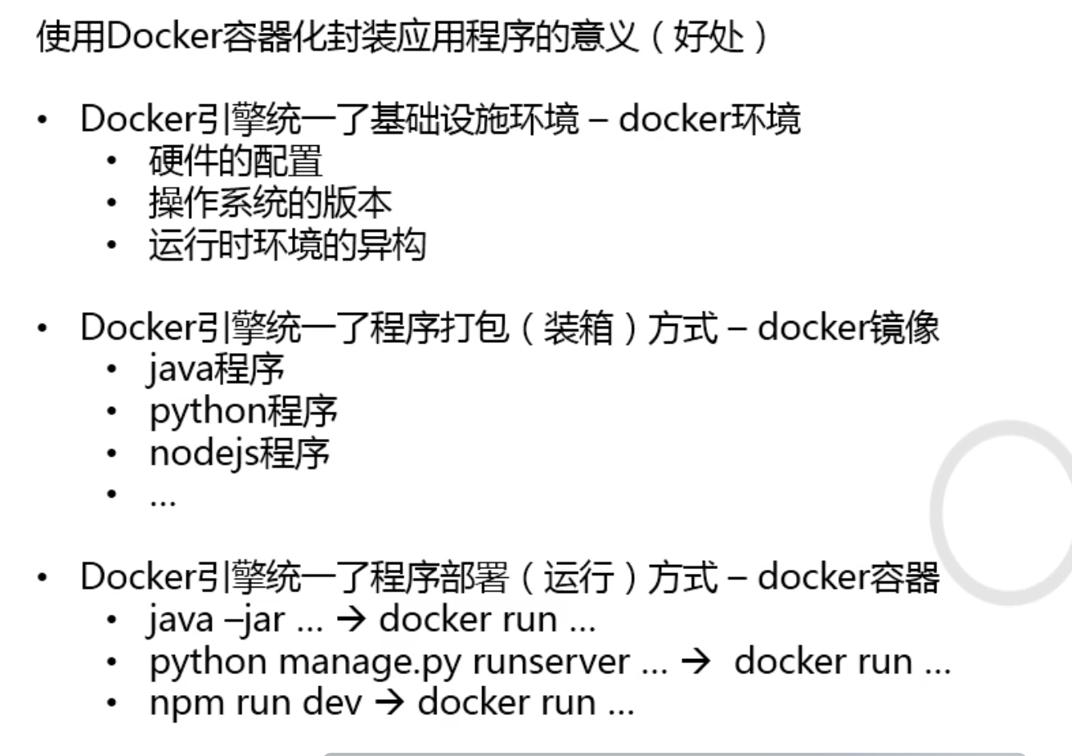

## 缺点

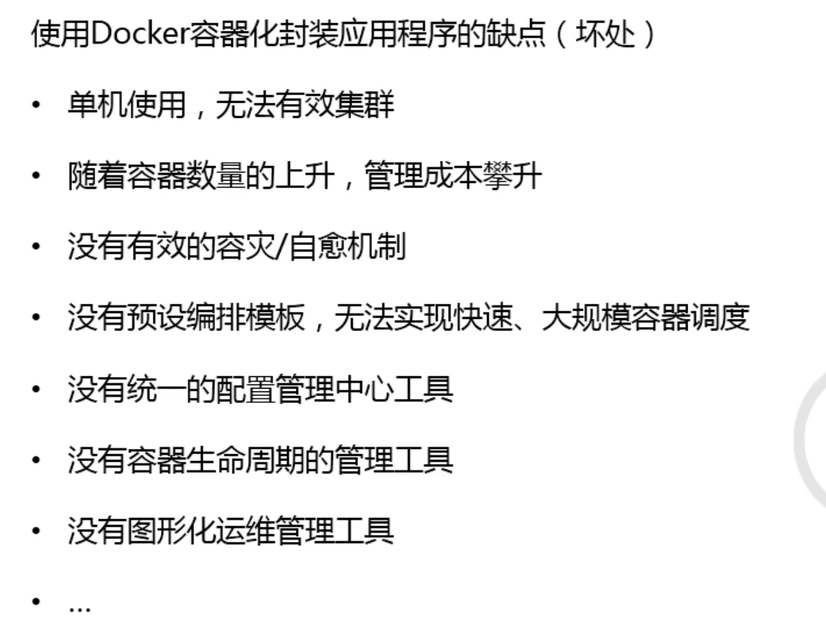

## 编排工具

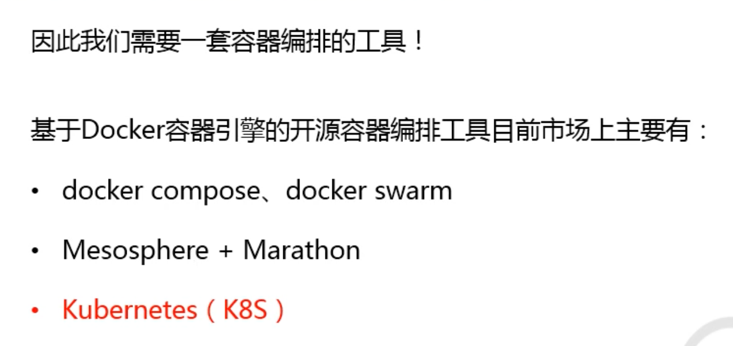

# k8s介绍

## 概述

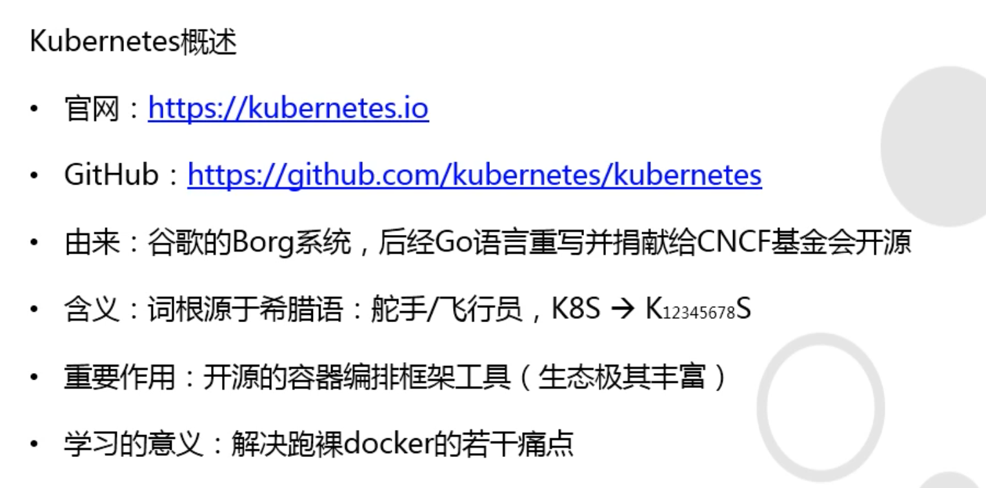

## 优势

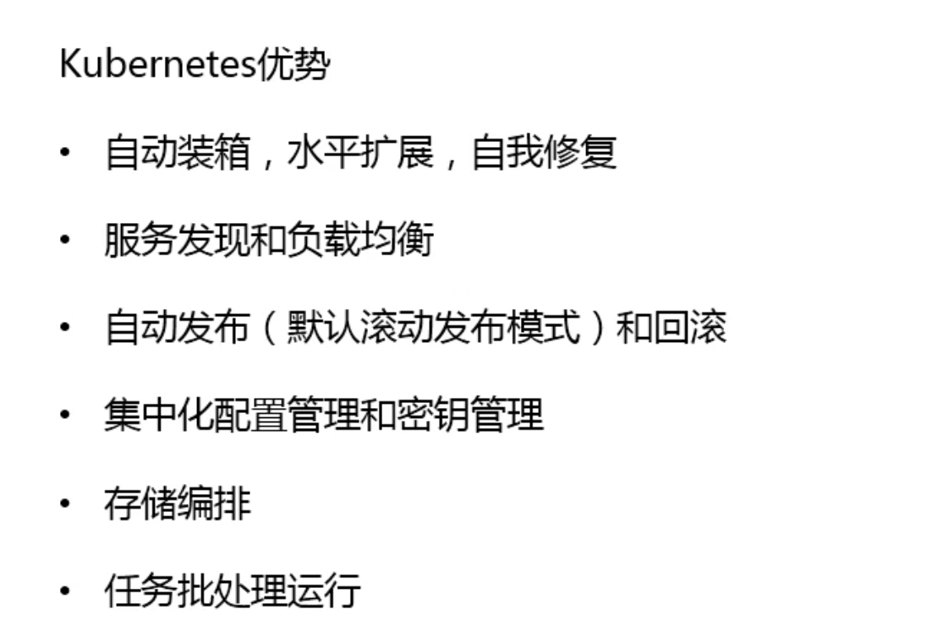

## 基本概念

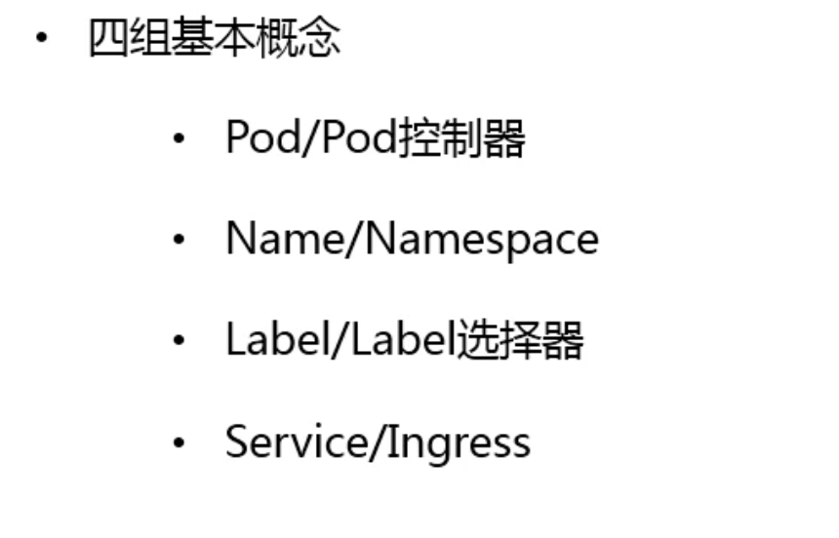

## Pod

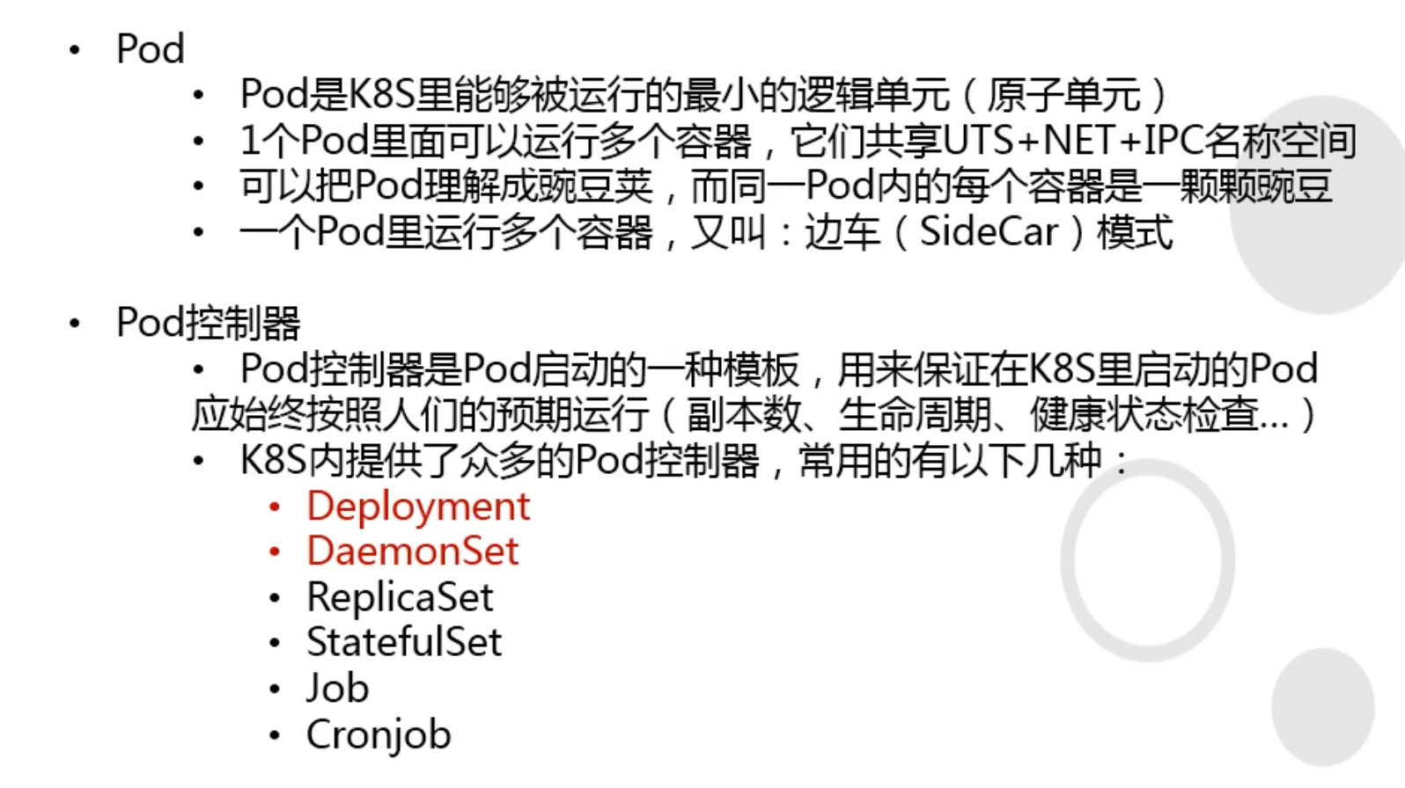

## Name/Namespace

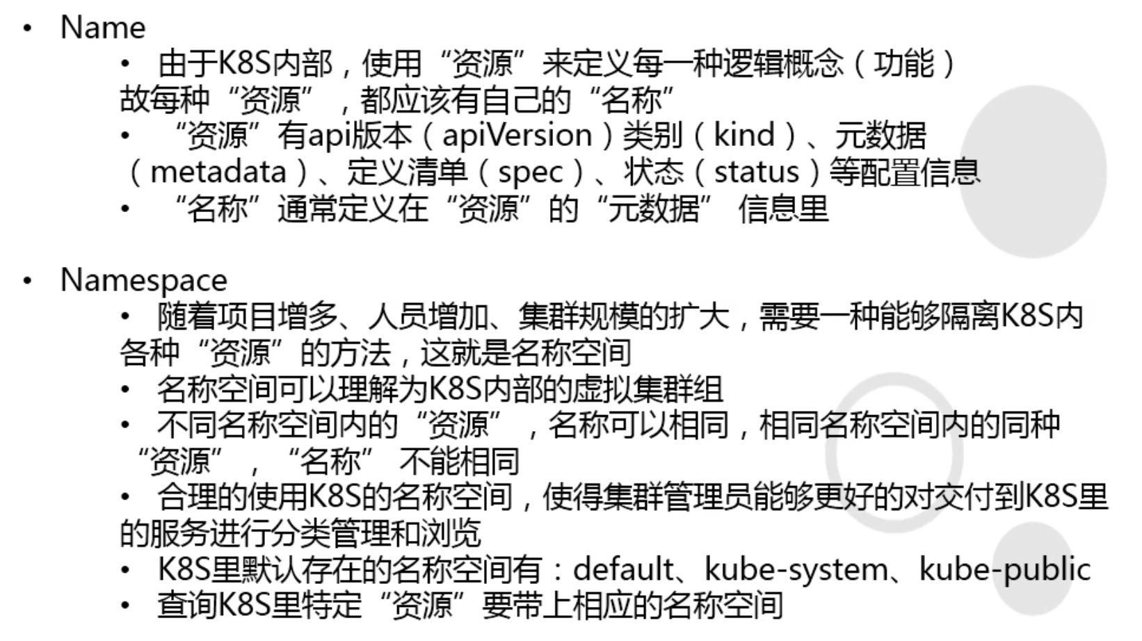

## Label/Label选择器

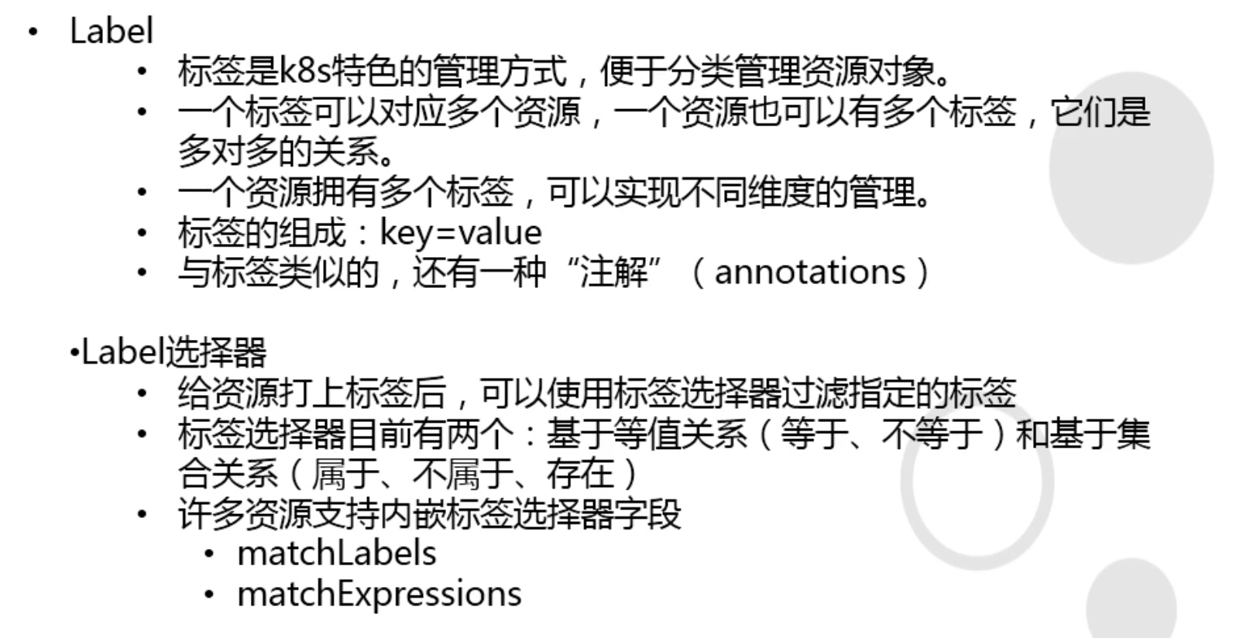

## Service/Ingress

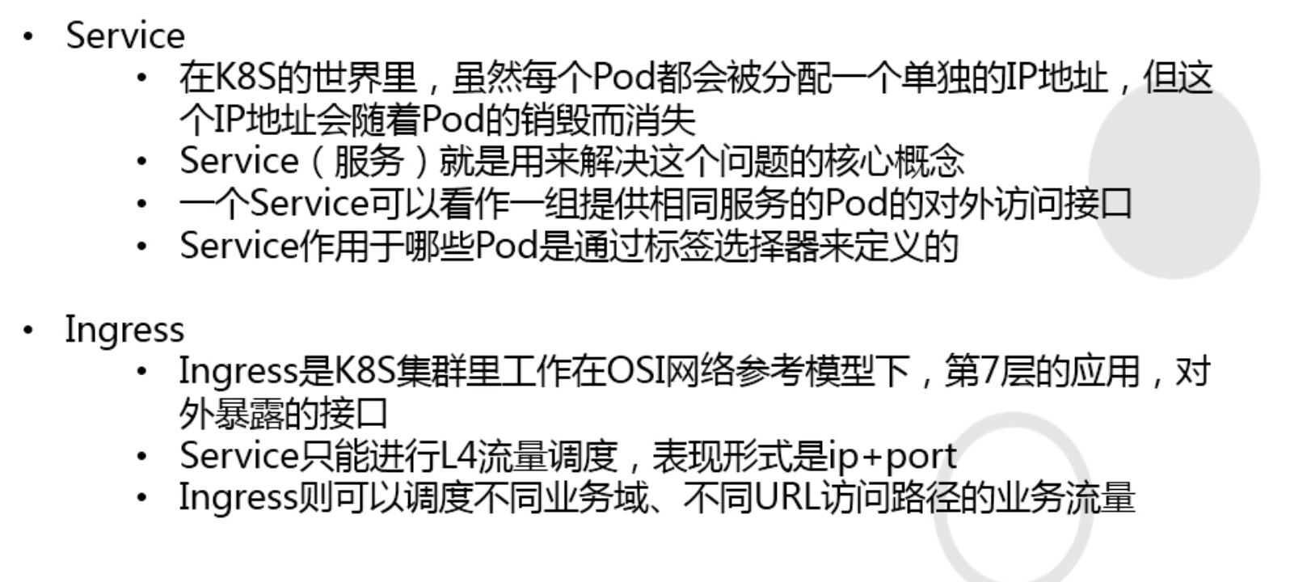

# 核心组件介绍

## apiserver

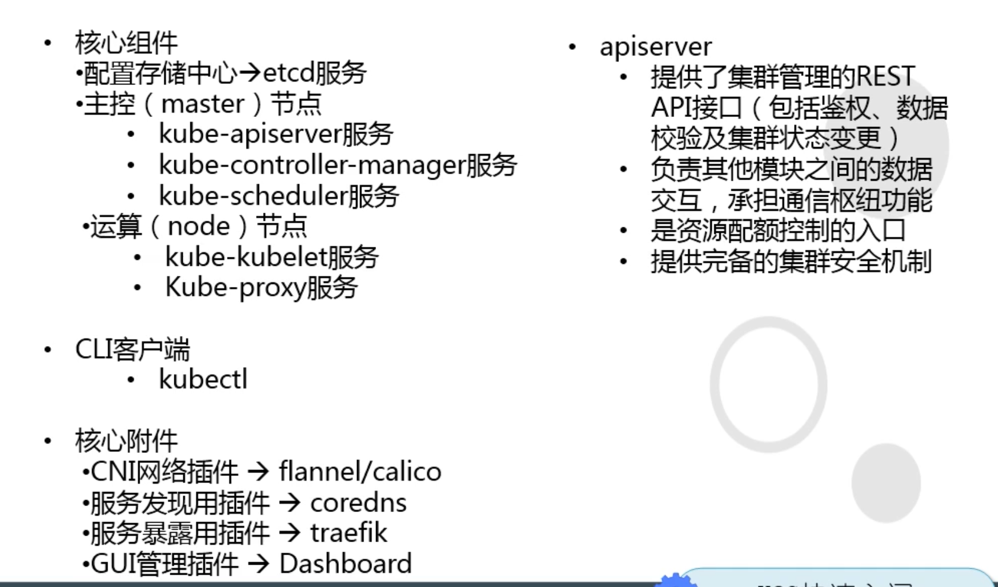

## controller-manager

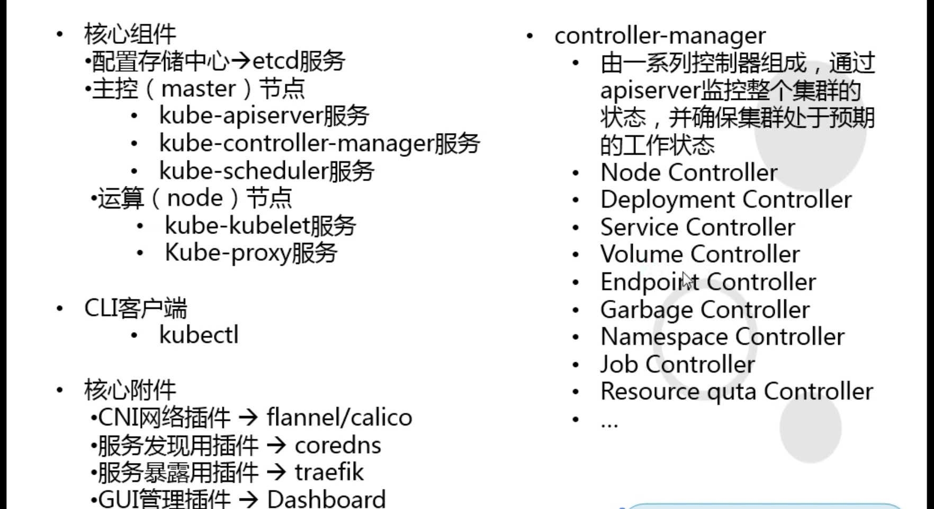

## scheduler

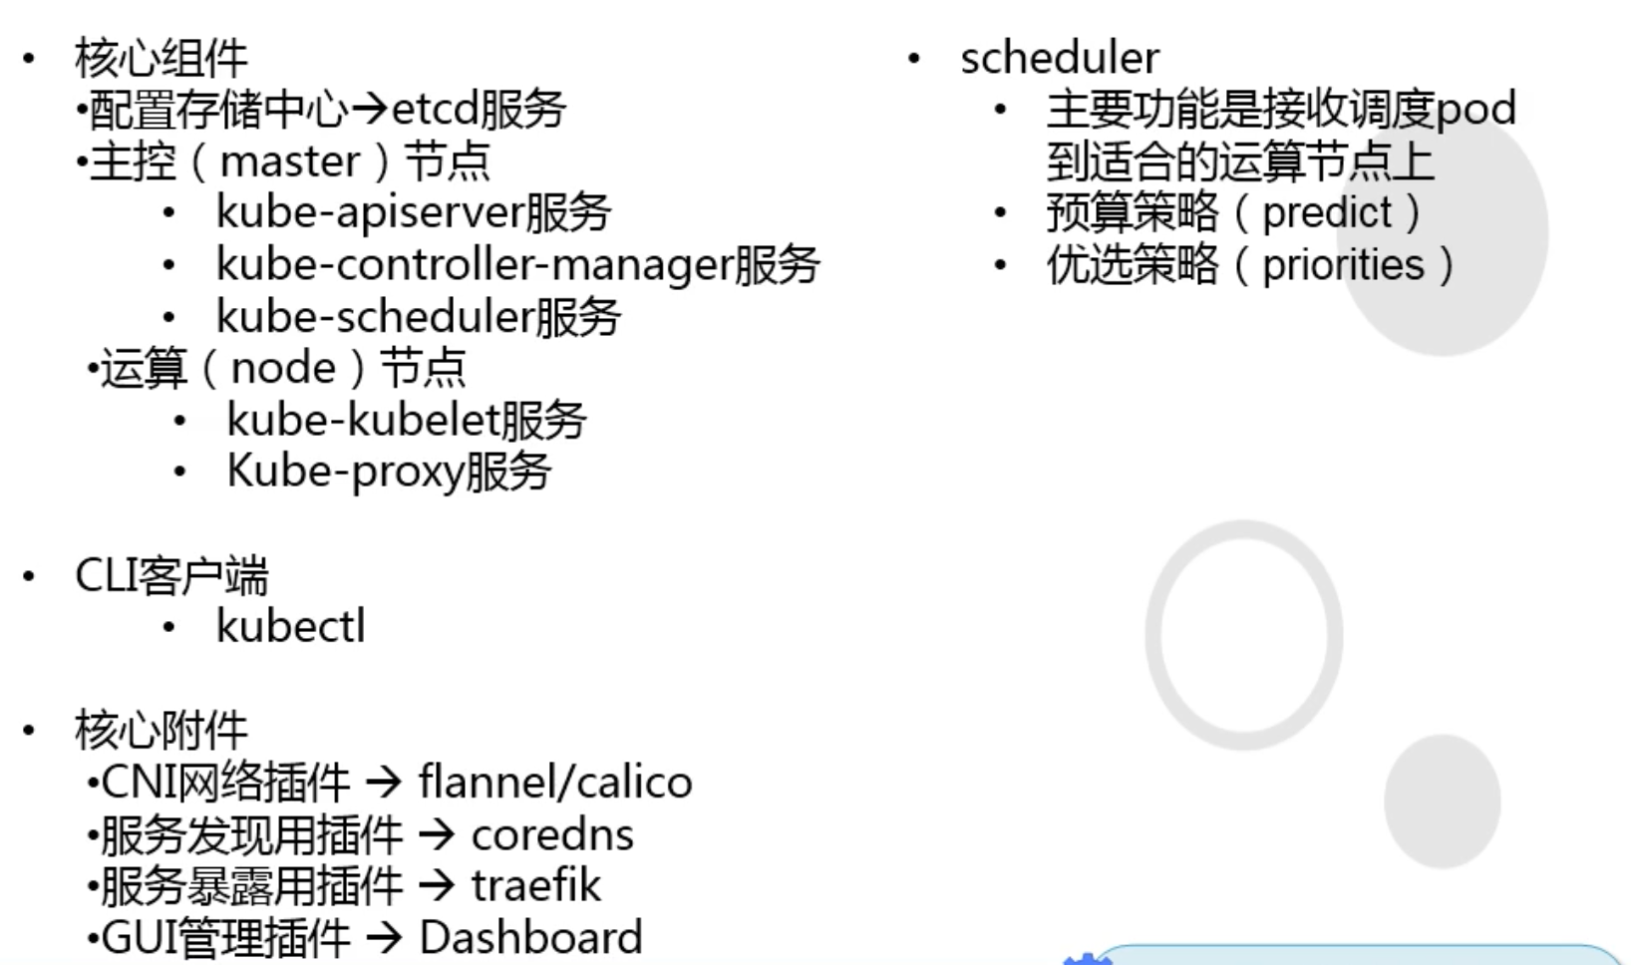

## kubelet

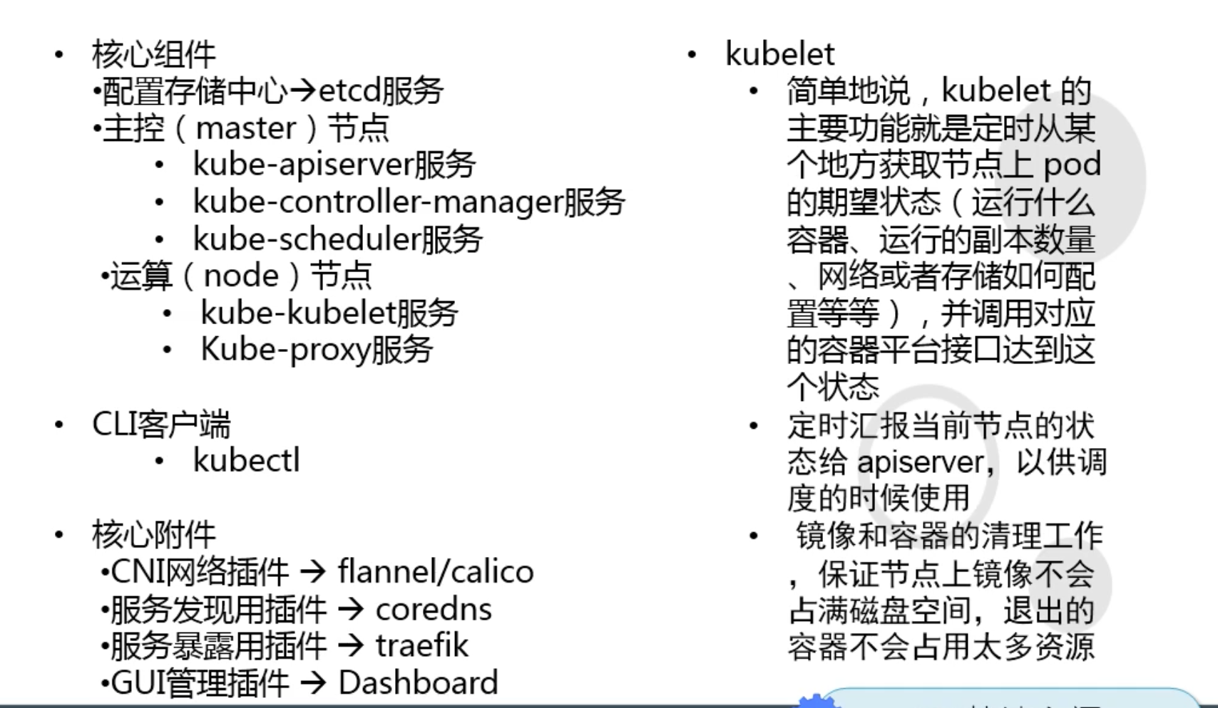

## kube-proxy

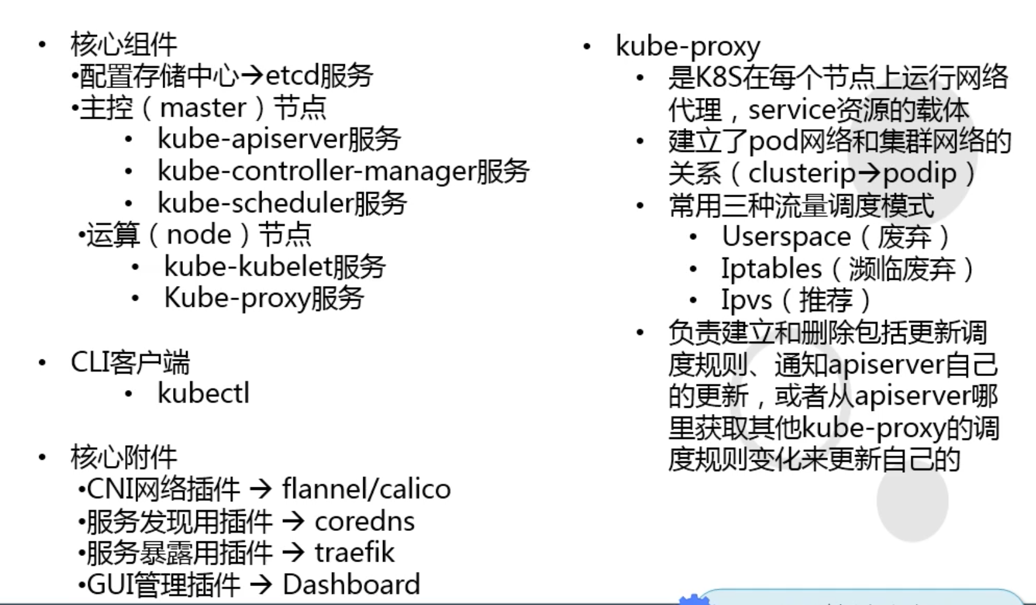

## k8s三条网络

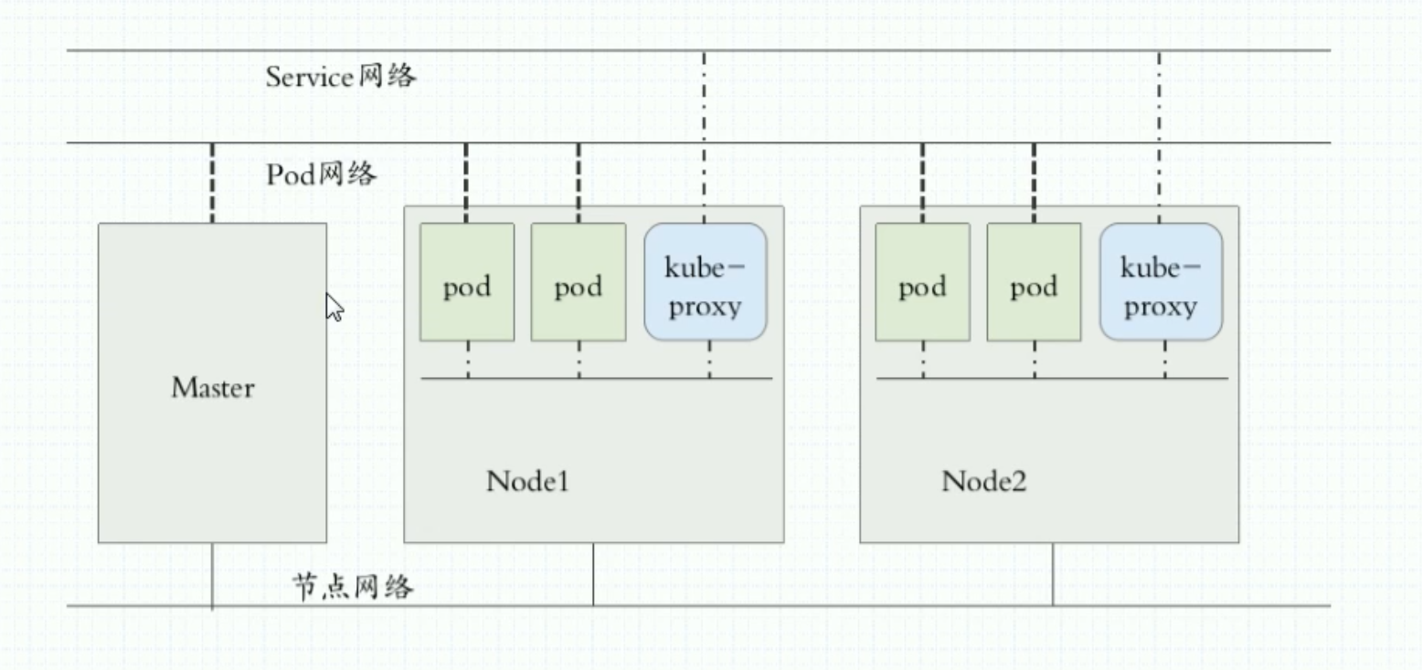

## 逻辑架构

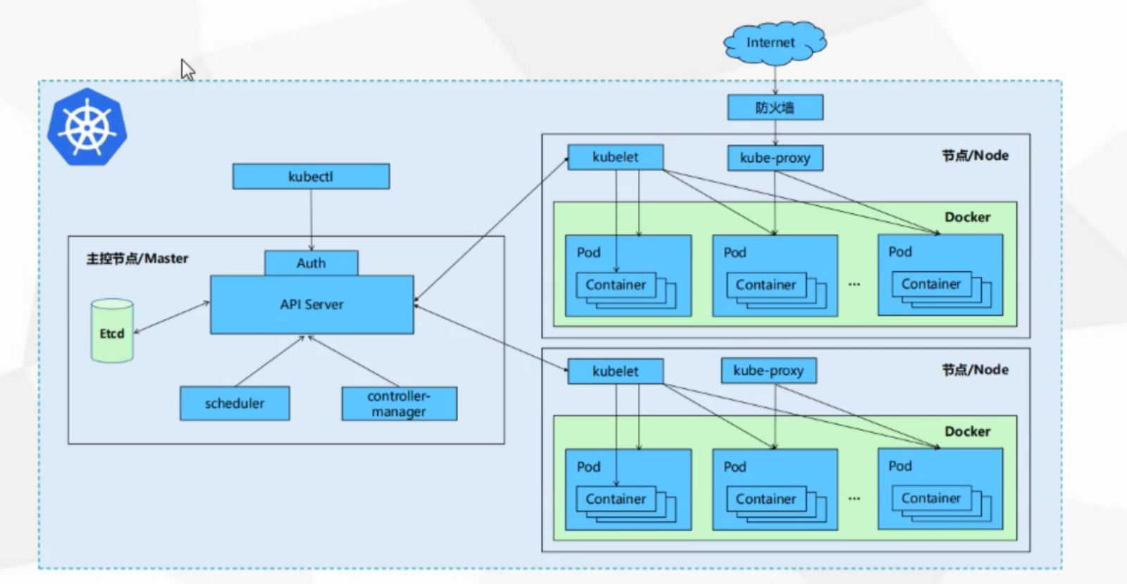

## 知识梳理

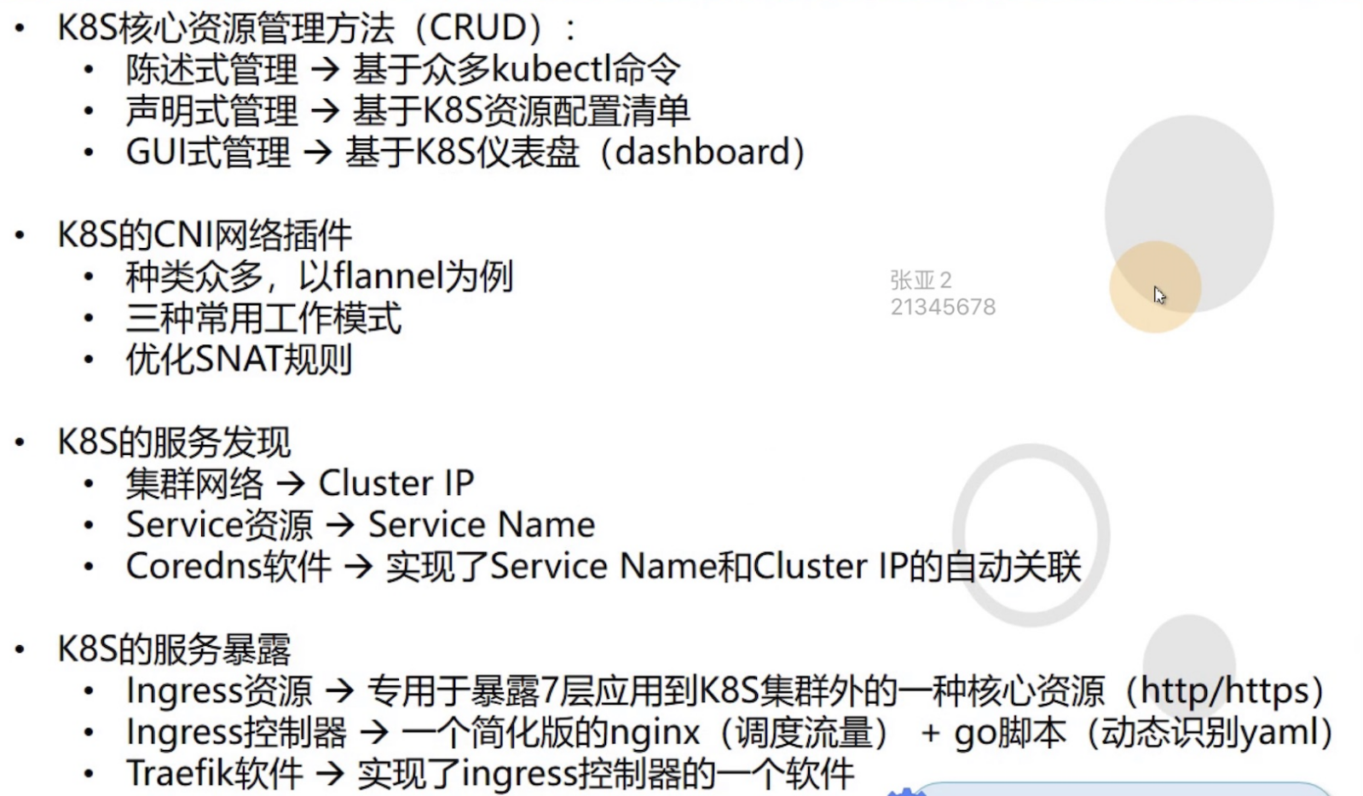

# 实验环境

## 实验架构图

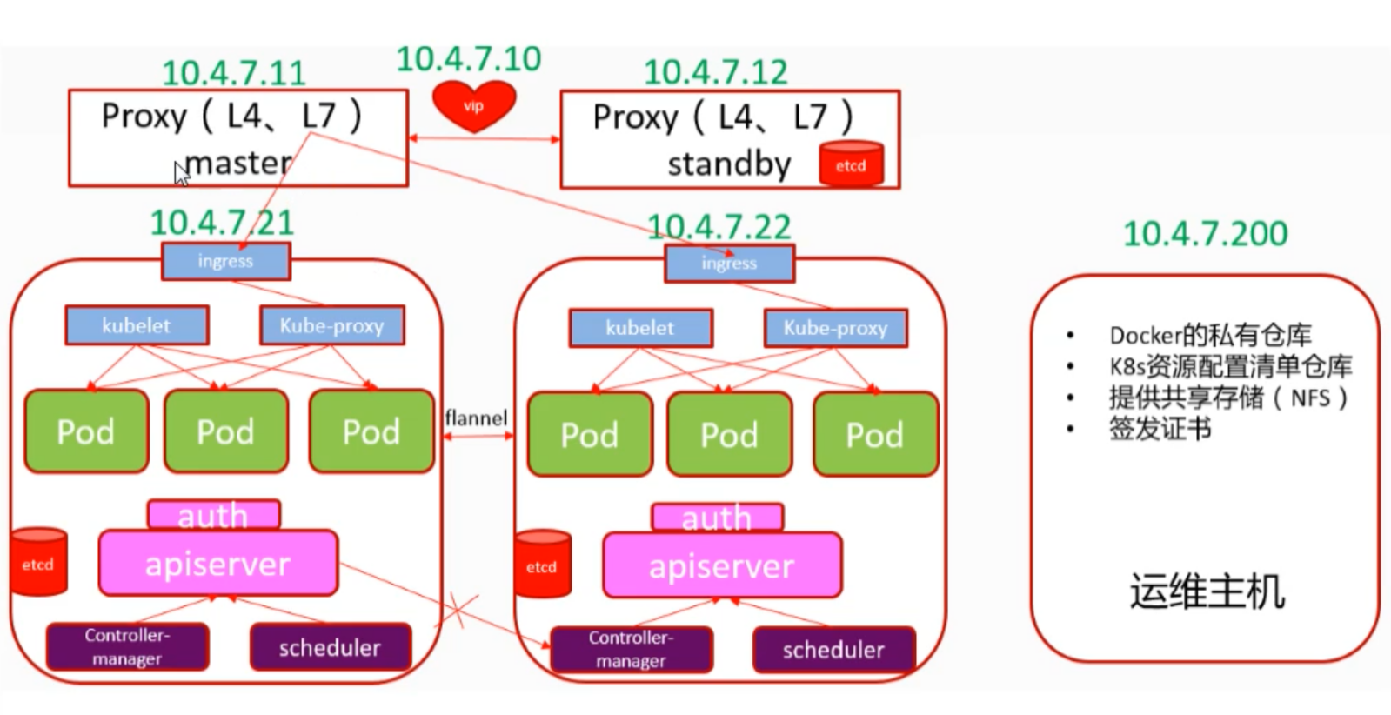

## 安装部署方式

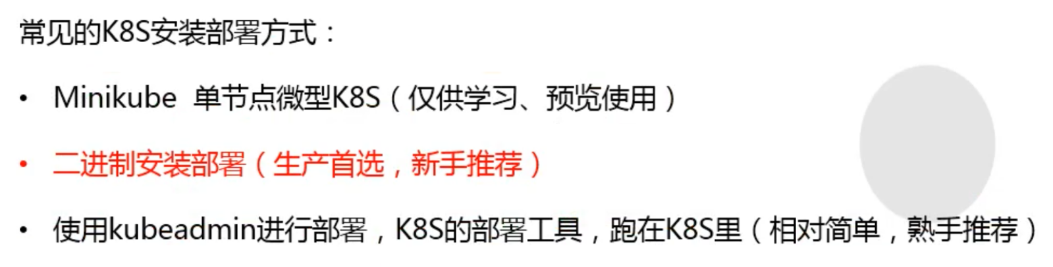

# 虚拟机准备环境

## 实验环境准备介绍

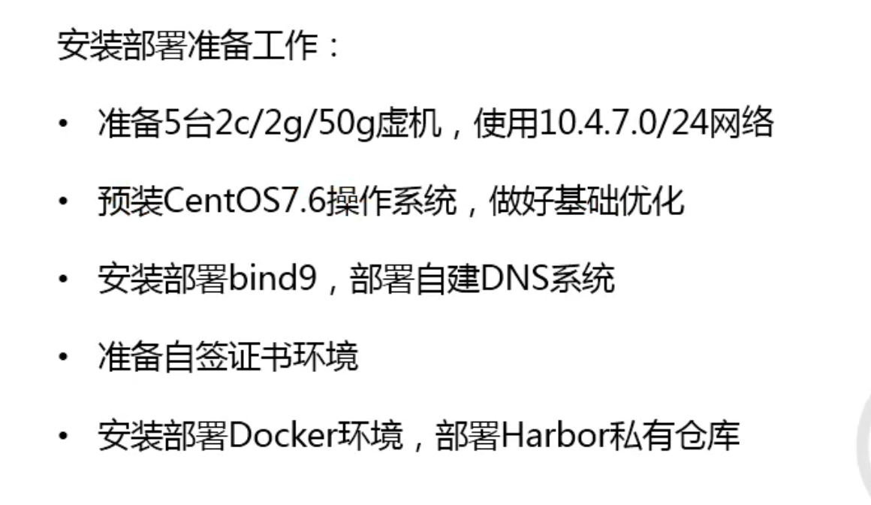

## 实验环境检查

关闭selinux和防火墙

查看内核版本

[root@hdss7-11 ~]# uname -a

Linux hdss7-11.host.com 3.10.0-957.21.3.el7.x86_64 #1 SMP Tue Jun 18 16:35:19 UTC 2019 x86_64 x86_64 x86_64 GNU/Linux

## 配置yum源和epel源

curl -o /etc/yum.repos.d/CentOS-Base.repo http://mirrors.aliyun.com/repo/Centos-7.repo

curl -o /etc/yum.repos.d/epel.repo http://mirrors.aliyun.com/repo/epel-7.repo

## 安装必备工具

yum install bash-completion bash-completion-extras wget net-tools telnet tree nmap sysstat lrzsz dos2unix bind-utils ntpdate -y

## 配置时间同步

*/5 * * * * /sbin/ntpdate time1.aliyun.com > /dev/null 2>&1

## 升级内核

uname -r

rpm --import https://www.elrepo.org/RPM-GPG-KEY-elrepo.org

rpm -Uvh http://www.elrepo.org/elrepo-release-7.0-2.el7.elrepo.noarch.rpm

yum --enablerepo=elrepo-kernel install kernel-ml-devel kernel-ml -y

grub2-set-default 0

reboot

uname -r

# DNS服务配置

## 安装bind9

在hdss7-11上执行

[root@hdss7-11 ~]# yum install bind -y

## 修改配置文件

[root@hdss7-11 ~]# vim /etc/named.conf

13 listen-on port 53 { 10.0.0.11; };

20 allow-query { any; };

21 forwarders { 10.0.0.254; };

35 dnssec-enable no;

36 dnssec-validation no;

## 配置区域文件

[root@hdss7-11 ~]# vim /etc/named.rfc1912.zones

43 zone "host.com" IN {

44 type master;

45 file "host.com.zone";

46 allow-update { 10.0.0.11; };

47 };

48

49 zone "od.com" IN {

50 type master;

51 file "od.com.zone";

52 allow-update { 10.0.0.11; };

53 };

## 编辑区域主机数据文件

[root@hdss7-11 ~]# vim /var/named/host.com.zone

$ORIGIN host.com.

$TTL 600 ; 10 minutes

@ IN SOA dns.host.com. dnsadmin.host.com. (

2019111001 ; serial

10800 ; refresh (3 hours)

900 ; retry (15 minutes)

604800 ; expire (1 week)

86400 ; minimum (1 day)

)

NS dns.host.com.

$TTL 60 ; 1 minute

dns A 10.0.0.11

HDSS7-11 A 10.0.0.11

HDSS7-12 A 10.0.0.12

HDSS7-21 A 10.0.0.21

HDSS7-22 A 10.0.0.22

HDSS7-200 A 10.0.0.200

## 配置业务域数据文件

[root@hdss7-11 ~]# vim /var/named/od.com.zone

$ORIGIN od.com.

$TTL 600 ; 10 minutes

@ IN SOA dns.od.com. dnsadmin.od.com. (

2019111601 ; serial

10800 ; refresh (3 hours)

900 ; retry (15 minutes)

604800 ; expire (1 week)

86400 ; minimum (1 day)

)

NS dns.od.com.

$TTL 60 ; 1 minute

dns A 10.0.0.11

## 检查语法

[root@hdss7-11 ~]# named-checkconf

[root@hdss7-11 ~]#

## 启动服务

[root@hdss7-11 ~]# systemctl start named

[root@hdss7-11 ~]# netstat -lntup|grep "named"

## 检查服务是否正常解析

[root@hdss7-11 ~]# dig -t A hdss7-21.host.com @10.0.0.11 +short

10.0.0.21

[root@hdss7-11 ~]# dig -t A hdss7-200.host.com @10.0.0.11 +short

10.0.0.200

## 修改客户端使用DNS服务

修改网卡配置文件并重启服务

[root@hdss7-11 ~]# cat /etc/sysconfig/network-scripts/ifcfg-eth0 |grep DNS

DNS1=10.0.0.11

[root@hdss7-11 ~]# systemctl restart network

## 检查并测试

[root@hdss7-11 ~]# cat /etc/resolv.conf

# Generated by NetworkManager

search host.com

nameserver 10.0.0.11

[root@hdss7-11 ~]# ping www.baidu.com

PING www.a.shifen.com (61.135.169.121) 56(84) bytes of data.

64 bytes from 61.135.169.121 (61.135.169.121): icmp_seq=1 ttl=56 time=5.81 ms

64 bytes from 61.135.169.121 (61.135.169.121): icmp_seq=2 ttl=56 time=6.03 ms

[root@hdss7-11 ~]# ping hdss7-11.host.com

PING HDSS7-11.host.com (10.0.0.11) 56(84) bytes of data.

64 bytes from hdss7-11.host.com (10.0.0.11): icmp_seq=1 ttl=64 time=0.047 ms

64 bytes from hdss7-11.host.com (10.0.0.11): icmp_seq=2 ttl=64 time=0.079 ms

## 修改其他主机

修改其他所有主机并测试

vim /etc/sysconfig/network-scripts/ifcfg-eth0 |grep DNS

systemctl restart network

ping www.baidu.com

ping hdss7-11.host.com

## 配置DNS客户端

注意！所有主机的DNS文件需要添加一行search host.com，不然解析不了短域名

[root@hdss7-11 ~]# cat /etc/resolv.conf

# Generated by NetworkManager

search host.com

nameserver 10.0.0.11

[root@hdss7-11 ~]# ping hdss7-200

PING HDSS7-200.host.com (10.0.0.200) 56(84) bytes of data.

64 bytes from 10.0.0.200: icmp_seq=1 ttl=64 time=0.262 ms

## windows修改网卡DNS

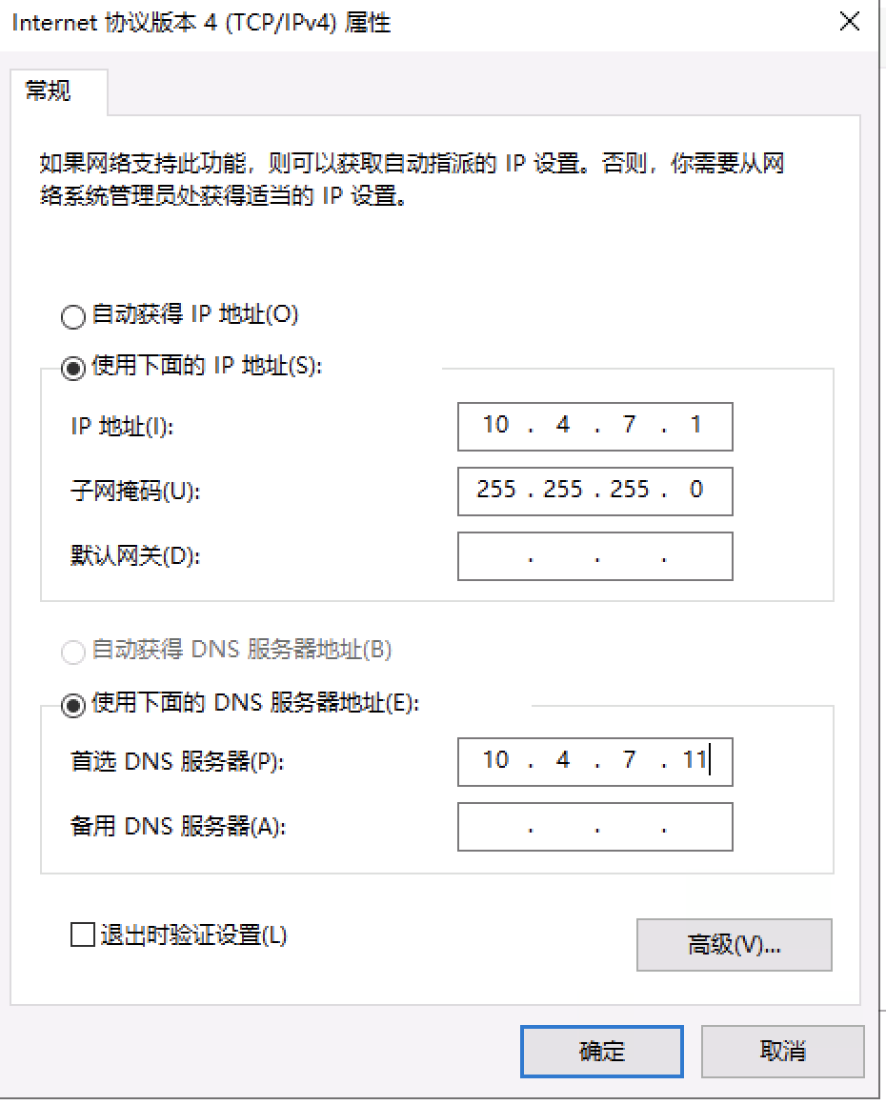

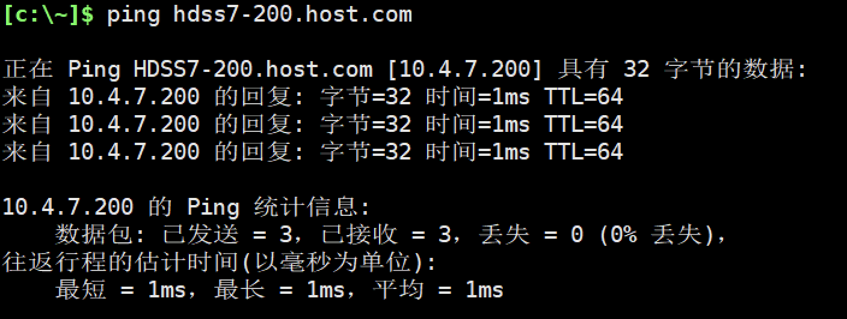

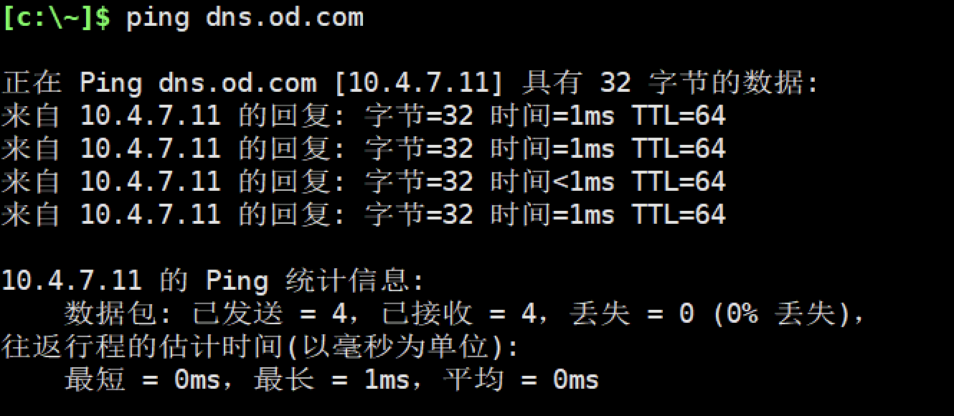

# 准备签发证书环境

运行在HDSS7-200.host,coms上

## 安装CFSSL

[root@hdss7-200 ~]# wget https://pkg.cfssl.org/R1.2/cfssl_linux-amd64 -O /usr/bin/cfssl

[root@hdss7-200 ~]# wget https://pkg.cfssl.org/R1.2/cfssljson_linux-amd64 -O /usr/bin/cfssl-json

[root@hdss7-200 ~]# wget https://pkg.cfssl.org/R1.2/cfssl-certinfo_linux-amd64 -O /usr/bin/cfssl-certinfo

[root@hdss7-200 ~]# chmod +x /usr/bin/cfssl*

## 创建生成CA证书签名请求（csr）的JSON配置文件

[root@hdss7-200 ~]# mkdir /opt/certs

[root@hdss7-200 ~]# vim /opt/certs/ca-csr.json

[root@hdss7-200 ~]# cat /opt/certs/ca-csr.json

{

"CN": "OldboyEdu",

"hosts": [

],

"key": {

"algo": "rsa",

"size": 2048

},

"names": [

{

"C": "CN",

"ST": "beijing",

"L": "beijing",

"O": "od",

"OU": "ops"

}

],

"ca": {

"expiry": "175200h"

}

}

## 生成CA证书和私钥

[root@hdss7-200 ~]# cd /opt/certs/

[root@hdss7-200 certs]# cfssl gencert -initca ca-csr.json | cfssl-json -bare ca

2019/11/16 13:57:02 [INFO] generating a new CA key and certificate from CSR

2019/11/16 13:57:02 [INFO] generate received request

2019/11/16 13:57:02 [INFO] received CSR

2019/11/16 13:57:02 [INFO] generating key: rsa-2048

2019/11/16 13:57:04 [INFO] encoded CSR

2019/11/16 13:57:04 [INFO] signed certificate with serial number 254830484213975612609560018938046286824479834173

[root@hdss7-200 certs]# ll

total 16

-rw-r--r-- 1 root root 328 Nov 16 13:31 ca-csr.json

-rw------- 1 root root 1679 Nov 16 13:57 ca-key.pem

-rw-r--r-- 1 root root 993 Nov 16 13:57 ca.csr

-rw-r--r-- 1 root root 1346 Nov 16 13:57 ca.pem

# 部署docker环境

部署在HDSS7-200.host.com,HDSS7-21.host.com,HDSS7-22.host.com上

## 安装

curl -fsSL https://get.docker.com | bash -s docker --mirror Aliyun

## 配置

############配置说明###############

注意！bip要根据宿主机ip变化

hdss7-21.host.com bip 172.7.21.1/24

hdss7-22.host.com bip 172.7.22.1/24

hdss7-200.host.com bip 172.7.200.1/24

#################################

mkdir /etc/docker

mkdir /data/docker -p

cat > /etc/docker/daemon.json << 'EOF'

{

"graph": "/data/docker",

"storage-driver": "overlay2",

"insecure-registries": ["registry.access.redhat.com","quay.io","harbor.od.com"],

"registry-mirrors": ["https://q2gr04ke.mirror.aliyuncs.com"],

"bip": "172.7.21.1/24",

"exec-opts": ["native.cgroupdriver=systemd"],

"live-restore": true

}

EOF

## 启动

systemctl start docker

## 检查

docker version

docker info

docker ps

# 部署docker镜像私有仓库harbor

在HDSS7-200.host.com上执行

## 下载harbor离线安装包并解压

mkdir /opt/src/harbor -p

mkdir /data/harbor/logs -p

cd /opt/src/harbor

tar zxf harbor-offline-installer-v1.8.3.tgz -C /opt

cd /opt

mv harbor harbor-v1.8.3

ln -s harbor-v1.8.3 harbor

yum install docker-compose -y

## 配置

cd /opt/harbor/

vim harbor.yml

hostname: harbor.od.com

http:

port: 180

data_volume: /data/harbor

location: /data/harbor/logs

## 安装

cd /opt/harbor/

./install.sh

## 配置Nginx代理

### 配置源

[root@hdss7-200 ~]# vim /etc/yum.repos.d/nginx.repo

[nginx-stable]

name=nginx stable repo

baseurl=http://nginx.org/packages/centos/$releasever/$basearch/

gpgcheck=1

enabled=1

gpgkey=https://nginx.org/keys/nginx_signing.key

module_hotfixes=true

[nginx-mainline]

name=nginx mainline repo

baseurl=http://nginx.org/packages/mainline/centos/$releasever/$basearch/

gpgcheck=1

enabled=0

gpgkey=https://nginx.org/keys/nginx_signing.key

module_hotfixes=true

### 安装Nginx

[root@hdss7-200 ~]# yum install nginx -y

### 配置子配置文件

[root@hdss7-200 ~]# cat > /etc/nginx/conf.d/harbor.od.com.conf << 'EOF'

server {

listen 80;

server_name harbor.od.com;

client_max_body_size 1000m;

location / {

proxy_pass http://127.0.0.1:180;

}

}

EOF

### 启动Nginx

[root@hdss7-200 ~]# systemctl start nginx

[root@hdss7-200 ~]# systemctl enable nginx

## 配置DNS解析harbor地址

HDSS7-11上操作

### 修改配置文件

[root@hdss7-11 ~]# cat /var/named/od.com.zone

$ORIGIN od.com.

$TTL 600 ; 10 minutes

@ IN SOA dns.od.com. dnsadmin.od.com. (

2019111602 ; serial

10800 ; refresh (3 hours)

900 ; retry (15 minutes)

604800 ; expire (1 week)

86400 ; minimum (1 day)

)

NS dns.od.com.

$TTL 60 ; 1 minute

dns A 10.0.0.11

harbor A 10.0.0.200

### 重启服务

[root@hdss7-11 ~]# systemctl restart named

### 测试解析

[root@hdss7-11 ~]# dig -t A harbor.od.com +short

10.0.0.200

## 浏览器访问新建仓库



## 拉取镜像改名上传到harbor

[root@hdss7-200 ~]# docker pull docker.io/library/nginx:1.7.9

[root@hdss7-200 ~]# docker images|grep 1.7.9

nginx 1.7.9 84581e99d807 4 years ago 91.7MB

[root@hdss7-200 ~]# docker tag 84581e99d807 harbor.od.com/public/nginx:v1.7.9

[root@hdss7-200 ~]# docker login harbor.od.com

Username: admin

Password:

WARNING! Your password will be stored unencrypted in /root/.docker/config.json.

Configure a credential helper to remove this warning. See

https://docs.docker.com/engine/reference/commandline/login/#credentials-store

Login Succeeded

[root@hdss7-200 ~]# docker push harbor.od.com/public/nginx:v1.7.9

# 部署Master节点服务

## 部署etcd集群

注意！三个节点都要操作！

### 集群规划

|  |  |  |
| --- | --- | --- |
| 主机名 | 角色 | IP |
| HDSS7-12.host.com | etcd lead | 10.0.0.12 |
| HDSS7-21.host.com | etcd follow | 10.0.0.21 |
| HDSS7-22.host.com | etcd follow | 10.0.0.22 |

### 创建基于根证书的config配置文件

注意！在200的机器上操作

[root@hdss7-200 ~]# cat > /opt/certs/ca-config.json << 'EOF'

{

"signing": {

"default": {

"expiry": "175200h"

},

"profiles": {

"server": {

"expiry": "175200h",

"usages": [

"signing",

"key encipherment",

"server auth"

]

},

"client": {

"expiry": "175200h",

"usages": [

"signing",

"key encipherment",

"client auth"

]

},

"peer": {

"expiry": "175200h",

"usages": [

"signing",

"key encipherment",

"server auth",

"client auth"

]

}

}

}

}

EOF

### 创建生成自签证书签名请求(csr)的json配置文件

[root@hdss7-200 ~]# cat > /opt/certs/etcd-peer-csr.json << 'EOF'

{

"CN": "k8s-etcd",

"hosts": [

"10.0.0.11",

"10.0.0.12",

"10.0.0.21",

"10.0.0.22"

],

"key": {

"algo": "rsa",

"size": 2048

},

"names": [

{

"C": "CN",

"ST": "beijing",

"L": "beijing",

"O": "od",

"OU": "ops"

}

]

}

EOF

### 生成etcd证书和私钥

[root@hdss7-200 ~]# cd /opt/certs/

[root@hdss7-200 certs]# cfssl gencert -ca=ca.pem -ca-key=ca-key.pem -config=ca-config.json -profile=peer etcd-peer-csr.json |cfssl-json -bare etcd-peer

### 检查生成的证书和私钥

[root@hdss7-200 certs]# ll

total 36

-rw-r--r-- 1 root root 836 Nov 16 15:55 ca-config.json

-rw-r--r-- 1 root root 328 Nov 16 13:31 ca-csr.json

-rw------- 1 root root 1679 Nov 16 13:57 ca-key.pem

-rw-r--r-- 1 root root 993 Nov 16 13:57 ca.csr

-rw-r--r-- 1 root root 1346 Nov 16 13:57 ca.pem

-rw-r--r-- 1 root root 363 Nov 16 15:56 etcd-peer-csr.json

-rw------- 1 root root 1675 Nov 16 16:03 etcd-peer-key.pem

-rw-r--r-- 1 root root 1062 Nov 16 16:03 etcd-peer.csr

-rw-r--r-- 1 root root 1428 Nov 16 16:03 etcd-peer.pem

### 创建etcd用户

3个etcd节点操作，12，21，22服务器

useradd -M -s /sbin/nologin etcd

id etcd

### 下载软件，解压，创建软连接

mkdir /opt/src

cd /opt/src

tar zxf etcd-v3.1.20-linux-amd64.tar.gz -C /opt/

cd /opt

mv etcd-v3.1.20-linux-amd64 etcd-v3.1.20

ln -s /opt/etcd-v3.1.20 /opt/etcd

### 创建目录，拷贝证书，私钥

mkdir -p /opt/etcd/certs /data/etcd /data/logs/etcd-server

cd /opt/etcd/certs/

scp hdss7-200:/opt/certs/ca.pem .

scp hdss7-200:/opt/certs/etcd-peer.pem .

scp hdss7-200:/opt/certs/etcd-peer-key.pem .

### 创建etcd服务启动脚本

cat > /opt/etcd/etcd-server-startup.sh <<'EOF'

#!/bin/sh

./etcd --name etcd-server-7-12 \

--data-dir /data/etcd/etcd-server \

--listen-peer-urls https://10.0.0.12:2380 \

--listen-client-urls https://10.0.0.12:2379,http://127.0.0.1:2379 \

--quota-backend-bytes 8000000000 \

--initial-advertise-peer-urls https://10.0.0.12:2380 \

--advertise-client-urls https://10.0.0.12:2379,http://127.0.0.1:2379 \

--initial-cluster etcd-server-7-12=https://10.0.0.12:2380,etcd-server-7-21=https://10.0.0.21:2380,etcd-server-7-22=https://10.0.0.22:2380 \

--ca-file ./certs/ca.pem \

--cert-file ./certs/etcd-peer.pem \

--key-file ./certs/etcd-peer-key.pem \

--client-cert-auth \

--trusted-ca-file ./certs/ca.pem \

--peer-ca-file ./certs/ca.pem \

--peer-cert-file ./certs/etcd-peer.pem \

--peer-key-file ./certs/etcd-peer-key.pem \

--peer-client-cert-auth \

--peer-trusted-ca-file ./certs/ca.pem \

--log-output stdout

EOF

### 调整权限

chmod +x /opt/etcd/etcd-server-startup.sh

chown -R etcd:etcd /opt/etcd-v3.1.20/

chown -R etcd:etcd /data/etcd/

chown -R etcd:etcd /data/logs/etcd-server/

### 安装supervisor软件

yum install supervisor -y

systemctl start supervisord

systemctl enable supervisord

### 创建etcd-server的启动配置

cat > /etc/supervisord.d/etcd-server.ini <<'EOF'

[program:etcd-server-7-12]

command=/opt/etcd/etcd-server-startup.sh ; the program (relative uses PATH, can take args)

numprocs=1 ; number of processes copies to start (def 1)

directory=/opt/etcd ; directory to cwd to before exec (def no cwd)

autostart=true ; start at supervisord start (default: true)

autorestart=true ; retstart at unexpected quit (default: true)

startsecs=30 ; number of secs prog must stay running (def. 1)

startretries=3 ; max # of serial start failures (default 3)

exitcodes=0,2 ; 'expected' exit codes for process (default 0,2)

stopsignal=QUIT ; signal used to kill process (default TERM)

stopwaitsecs=10 ; max num secs to wait b4 SIGKILL (default 10)

user=etcd ; setuid to this UNIX account to run the program

redirect_stderr=true ; redirect proc stderr to stdout (default false)

stdout_logfile=/data/logs/etcd-server/etcd.stdout.log ; stdout log path, NONE for none; default AUTO

stdout_logfile_maxbytes=64MB ; max # logfile bytes b4 rotation (default 50MB)

stdout_logfile_backups=4 ; # of stdout logfile backups (default 10)

stdout_capture_maxbytes=1MB ; number of bytes in 'capturemode' (default 0)

stdout_events_enabled=false ; emit events on stdout writes (default false)

EOF

### 启动etcd服务并检查

systemctl start supervisord.service

supervisorctl update

supervisorctl status

netstat -luntp|grep etcd

### 安装部署启动检查所有集群

21操作

useradd -M -s /sbin/nologin etcd

rsync -avz 10.0.0.12:/opt/etcd* .

mkdir -p /opt/etcd/certs /data/etcd /data/logs/etcd-server

chmod +x /opt/etcd/etcd-server-startup.sh

chown -R etcd:etcd /opt/etcd/

chown -R etcd:etcd /opt/etcd-v3.1.20/

chown -R etcd:etcd /data/etcd/

chown -R etcd:etcd /data/logs/etcd-server/

yum install supervisor -y

cat > /etc/supervisord.d/etcd-server.ini << 'EOF'

[program:etcd-server-7-21]

command=/opt/etcd/etcd-server-startup.sh ; the program (relative uses PATH, can take args)

numprocs=1 ; number of processes copies to start (def 1)

directory=/opt/etcd ; directory to cwd to before exec (def no cwd)

autostart=true ; start at supervisord start (default: true)

autorestart=true ; retstart at unexpected quit (default: true)

startsecs=30 ; number of secs prog must stay running (def. 1)

startretries=3 ; max # of serial start failures (default 3)

exitcodes=0,2 ; 'expected' exit codes for process (default 0,2)

stopsignal=QUIT ; signal used to kill process (default TERM)

stopwaitsecs=10 ; max num secs to wait b4 SIGKILL (default 10)

user=etcd ; setuid to this UNIX account to run the program

redirect_stderr=true ; redirect proc stderr to stdout (default false)

stdout_logfile=/data/logs/etcd-server/etcd.stdout.log ; stdout log path, NONE for none; default AUTO

stdout_logfile_maxbytes=64MB ; max # logfile bytes b4 rotation (default 50MB)

stdout_logfile_backups=4 ; # of stdout logfile backups (default 10)

stdout_capture_maxbytes=1MB ; number of bytes in 'capturemode' (default 0)

stdout_events_enabled=false ; emit events on stdout writes (default false)

EOF

cat > /opt/etcd/etcd-server-startup.sh << 'EOF'

#!/bin/sh

./etcd --name etcd-server-7-21 \

--data-dir /data/etcd/etcd-server \

--listen-peer-urls https://10.0.0.21:2380 \

--listen-client-urls https://10.0.0.21:2379,http://127.0.0.1:2379 \

--quota-backend-bytes 8000000000 \

--initial-advertise-peer-urls https://10.0.0.21:2380 \

--advertise-client-urls https://10.0.0.21:2379,http://127.0.0.1:2379 \

--initial-cluster etcd-server-7-12=https://10.0.0.12:2380,etcd-server-7-21=https://10.0.0.21:2380,etcd-server-7-22=https://10.0.0.22:2380 \

--ca-file ./certs/ca.pem \

--cert-file ./certs/etcd-peer.pem \

--key-file ./certs/etcd-peer-key.pem \

--client-cert-auth \

--trusted-ca-file ./certs/ca.pem \

--peer-ca-file ./certs/ca.pem \

--peer-cert-file ./certs/etcd-peer.pem \

--peer-key-file ./certs/etcd-peer-key.pem \

--peer-client-cert-auth \

--peer-trusted-ca-file ./certs/ca.pem \

--log-output stdout

EOF

systemctl start supervisord.service

supervisorctl update

supervisorctl status

netstat -luntp|grep etcd

22操作

scp -r 10.0.0.12:/opt/etcd* .

mkdir -p /opt/etcd/certs /data/etcd /data/logs/etcd-server

chmod +x /opt/etcd/etcd-server-startup.sh

chown -R etcd:etcd /opt/etcd/

chown -R etcd:etcd /opt/etcd-v3.1.20/

chown -R etcd:etcd /data/etcd/

chown -R etcd:etcd /data/logs/etcd-server/

yum install supervisor -y

cat > /etc/supervisord.d/etcd-server.ini << 'EOF'

[program:etcd-server-7-22]

command=/opt/etcd/etcd-server-startup.sh ; the program (relative uses PATH, can take args)

numprocs=1 ; number of processes copies to start (def 1)

directory=/opt/etcd ; directory to cwd to before exec (def no cwd)

autostart=true ; start at supervisord start (default: true)

autorestart=true ; retstart at unexpected quit (default: true)

startsecs=30 ; number of secs prog must stay running (def. 1)

startretries=3 ; max # of serial start failures (default 3)

exitcodes=0,2 ; 'expected' exit codes for process (default 0,2)

stopsignal=QUIT ; signal used to kill process (default TERM)

stopwaitsecs=10 ; max num secs to wait b4 SIGKILL (default 10)

user=etcd ; setuid to this UNIX account to run the program

redirect_stderr=true ; redirect proc stderr to stdout (default false)

stdout_logfile=/data/logs/etcd-server/etcd.stdout.log ; stdout log path, NONE for none; default AUTO

stdout_logfile_maxbytes=64MB ; max # logfile bytes b4 rotation (default 50MB)

stdout_logfile_backups=4 ; # of stdout logfile backups (default 10)

stdout_capture_maxbytes=1MB ; number of bytes in 'capturemode' (default 0)

stdout_events_enabled=false ; emit events on stdout writes (default false)

EOF

cat > /opt/etcd/etcd-server-startup.sh << 'EOF'

#!/bin/sh

./etcd --name etcd-server-7-22 \

--data-dir /data/etcd/etcd-server \

--listen-peer-urls https://10.0.0.22:2380 \

--listen-client-urls https://10.0.0.22:2379,http://127.0.0.1:2379 \

--quota-backend-bytes 8000000000 \

--initial-advertise-peer-urls https://10.0.0.22:2380 \

--advertise-client-urls https://10.0.0.22:2379,http://127.0.0.1:2379 \

--initial-cluster etcd-server-7-12=https://10.0.0.12:2380,etcd-server-7-21=https://10.0.0.21:2380,etcd-server-7-22=https://10.0.0.22:2380 \

--ca-file ./certs/ca.pem \

--cert-file ./certs/etcd-peer.pem \

--key-file ./certs/etcd-peer-key.pem \

--client-cert-auth \

--trusted-ca-file ./certs/ca.pem \

--peer-ca-file ./certs/ca.pem \

--peer-cert-file ./certs/etcd-peer.pem \

--peer-key-file ./certs/etcd-peer-key.pem \

--peer-client-cert-auth \

--peer-trusted-ca-file ./certs/ca.pem \

--log-output stdout

EOF

systemctl start supervisord.service

supervisorctl update

supervisorctl status

netstat -luntp|grep etcd

### 检查集群状态

[root@hdss7-12 etcd]# ./etcdctl cluster-health

member 988139385f78284 is healthy: got healthy result from http://127.0.0.1:2379

member 5a0ef2a004fc4349 is healthy: got healthy result from http://127.0.0.1:2379

member f4a0cb0a765574a8 is healthy: got healthy result from http://127.0.0.1:2379

cluster is healthy

[root@hdss7-12 etcd]# ./etcdctl member list

988139385f78284: name=etcd-server-7-22 peerURLs=https://10.0.0.22:2380 clientURLs=http://127.0.0.1:2379,https://10.0.0.22:2379 isLeader=false

5a0ef2a004fc4349: name=etcd-server-7-21 peerURLs=https://10.0.0.21:2380 clientURLs=http://127.0.0.1:2379,https://10.0.0.21:2379 isLeader=false

f4a0cb0a765574a8: name=etcd-server-7-12 peerURLs=https://10.0.0.12:2380 clientURLs=http://127.0.0.1:2379,https://10.0.0.12:2379 isLeader=true

## 部署kube-apiserver集群

### 集群规划

|  |  |  |
| --- | --- | --- |
| 主机名 | 角色 | IP |
| HDSS7-21.host.com | kube-apiserver | 10.0.0.21 |
| HDSS7-22.host.com | kube-apiserver | 10.0.0.22 |
| HDSS7-11.host.com | 4层负载均衡 | 10.0.0.11 |
| HDSS7-12.host.com | 4层负载均衡 | 10.0.0.12 |

注意：

这里10.0.0.11和10.0.0.12使用Nginx做4层负载均衡，用keepalived跑一个VIP：10.0.0.10，代理两个kube-apiversion，实现高可用

### 下载软件，解压，创建软链接

在21机器上执行：

cd /opt/src/

tar zxf kubernetes-server-linux-amd64-v1.15.2.tar.gz -C /opt/

cd /opt/

mv kubernetes kubernetes-v1.15.2

ln -s kubernetes-v1.15.2 kubernetes

cd /opt/kubernetes

rm -rf kubernetes-src.tar.gz

cd /opt/kubernetes/server/bin/

rm -f *.tar

rm -rf *_tag

### 签发client证书

在200机器上运行

cd /opt/certs/

cat > /opt/certs/client-csr.json << 'EOF'

{

"CN": "k8s-node",

"hosts": [

],

"key": {

"algo": "rsa",

"size": 2048

},

"names": [

{

"C": "CN",

"ST": "beijing",

"L": "beijing",

"O": "od",

"OU": "ops"

}

]

}

EOF

cfssl gencert -ca=ca.pem -ca-key=ca-key.pem -config=ca-config.json -profile=client client-csr.json |cfssl-json -bare client

### 签发kube-apiserver证书

cd /opt/certs/

cat > /opt/certs/apiserver-csr.json << 'EOF'

{

"CN": "k8s-apiserver",

"hosts": [

"127.0.0.1",

"192.168.0.1",

"kubernetes.default",

"kubernetes.default.svc",

"kubernetes.default.svc.cluster",

"kubernetes.default.svc.cluster.local",

"10.0.0.10",

"10.0.0.21",

"10.0.0.22",

"10.0.0.23"

],

"key": {

"algo": "rsa",

"size": 2048

},

"names": [

{

"C": "CN",

"ST": "beijing",

"L": "beijing",

"O": "od",

"OU": "ops"

}

]

}

EOF

cfssl gencert -ca=ca.pem -ca-key=ca-key.pem -config=ca-config.json -profile=server apiserver-csr.json |cfssl-json -bare apiserver

### 拷贝证书至各运算节点，并创建

21操作

cd /opt/kubernetes/server/bin/

mkdir cert

cd cert

scp hdss7-200:/opt/certs/ca.pem .

scp hdss7-200:/opt/certs/ca-key.pem .

scp hdss7-200:/opt/certs/client.pem .

scp hdss7-200:/opt/certs/client-key.pem .

scp hdss7-200:/opt/certs/apiserver.pem .

scp hdss7-200:/opt/certs/apiserver-key.pem .

### 创建配置

cd /opt/kubernetes/server/bin/

mkdir conf

cd conf

cat > audit.yaml << 'EOF'

apiVersion: audit.k8s.io/v1beta1 # This is required.

kind: Policy

# Don't generate audit events for all requests in RequestReceived stage.

omitStages:

- "RequestReceived"

rules:

# Log pod changes at RequestResponse level

- level: RequestResponse

resources:

- group: ""

# Resource "pods" doesn't match requests to any subresource of pods,

# which is consistent with the RBAC policy.

resources: ["pods"]

# Log "pods/log", "pods/status" at Metadata level

- level: Metadata

resources:

- group: ""

resources: ["pods/log", "pods/status"]

# Don't log requests to a configmap called "controller-leader"

- level: None

resources:

- group: ""

resources: ["configmaps"]

resourceNames: ["controller-leader"]

# Don't log watch requests by the "system:kube-proxy" on endpoints or services

- level: None

users: ["system:kube-proxy"]

verbs: ["watch"]

resources:

- group: "" # core API group

resources: ["endpoints", "services"]

# Don't log authenticated requests to certain non-resource URL paths.

- level: None

userGroups: ["system:authenticated"]

nonResourceURLs:

- "/api*" # Wildcard matching.

- "/version"

# Log the request body of configmap changes in kube-system.

- level: Request

resources:

- group: "" # core API group

resources: ["configmaps"]

# This rule only applies to resources in the "kube-system" namespace.

# The empty string "" can be used to select non-namespaced resources.

namespaces: ["kube-system"]

# Log configmap and secret changes in all other namespaces at the Metadata level.

- level: Metadata

resources:

- group: "" # core API group

resources: ["secrets", "configmaps"]

# Log all other resources in core and extensions at the Request level.

- level: Request

resources:

- group: "" # core API group

- group: "extensions" # Version of group should NOT be included.

# A catch-all rule to log all other requests at the Metadata level.

- level: Metadata

# Long-running requests like watches that fall under this rule will not

# generate an audit event in RequestReceived.

omitStages:

- "RequestReceived"

EOF

### 创建启动脚本

cat > /opt/kubernetes/server/bin/kube-apiserver.sh << 'EOF'

#!/bin/bash

./kube-apiserver \

--apiserver-count 2 \

--audit-log-path /data/logs/kubernetes/kube-apiserver/audit-log \

--audit-policy-file ./conf/audit.yaml \

--authorization-mode RBAC \

--client-ca-file ./cert/ca.pem \

--requestheader-client-ca-file ./cert/ca.pem \

--enable-admission-plugins NamespaceLifecycle,LimitRanger,ServiceAccount,DefaultStorageClass,DefaultTolerationSeconds,MutatingAdmissionWebhook,ValidatingAdmissionWebhook,ResourceQuota \

--etcd-cafile ./cert/ca.pem \

--etcd-certfile ./cert/client.pem \

--etcd-keyfile ./cert/client-key.pem \

--etcd-servers https://10.0.0.12:2379,https://10.0.0.21:2379,https://10.0.0.22:2379 \

--service-account-key-file ./cert/ca-key.pem \

--service-cluster-ip-range 192.168.0.0/16 \

--service-node-port-range 3000-29999 \

--target-ram-mb=1024 \

--kubelet-client-certificate ./cert/client.pem \

--kubelet-client-key ./cert/client-key.pem \

--log-dir /data/logs/kubernetes/kube-apiserver \

--tls-cert-file ./cert/apiserver.pem \

--tls-private-key-file ./cert/apiserver-key.pem \

--v 2

EOF

### 调整权限和目录

chmod +x kube-apiserver.sh

### 创建supervisor配置

cat > /etc/supervisord.d/kube-apiserver.ini << 'EOF'

[program:kube-apiserver-7-21]

command=/opt/kubernetes/server/bin/kube-apiserver.sh ; the program (relative uses PATH, can take args)

numprocs=1 ; number of processes copies to start (def 1)

directory=/opt/kubernetes/server/bin ; directory to cwd to before exec (def no cwd)

autostart=true ; start at supervisord start (default: true)

autorestart=true ; retstart at unexpected quit (default: true)

startsecs=30 ; number of secs prog must stay running (def. 1)

startretries=3 ; max # of serial start failures (default 3)

exitcodes=0,2 ; 'expected' exit codes for process (default 0,2)

stopsignal=QUIT ; signal used to kill process (default TERM)

stopwaitsecs=10 ; max num secs to wait b4 SIGKILL (default 10)

user=root ; setuid to this UNIX account to run the program

redirect_stderr=true ; redirect proc stderr to stdout (default false)

stdout_logfile=/data/logs/kubernetes/kube-apiserver/apiserver.stdout.log ; stderr log path, NONE for none; default AUTO

stdout_logfile_maxbytes=64MB ; max # logfile bytes b4 rotation (default 50MB)

stdout_logfile_backups=4 ; # of stdout logfile backups (default 10)

stdout_capture_maxbytes=1MB ; number of bytes in 'capturemode' (default 0)

stdout_events_enabled=false ; emit events on stdout writes (default false)

EOF

### 启动服务并检查

mkdir -p /data/logs/kubernetes/kube-apiserver

supervisorctl update

### 安装部署启动检查所有集群

22节点操作

rsync -avz 10.0.0.21:/opt/kubernetes* /opt/

rsync -avz 10.0.0.21:/etc/supervisord.d/kube-apiserver.ini /etc/supervisord.d/

sed -i 's#7-21#7-22#' /etc/supervisord.d/kube-apiserver.ini

mkdir -p /data/logs/kubernetes/kube-apiserver

supervisorctl update

supervisorctl status

### 配置4层反向代理

注意！在11和12机器上执行

scp 10.0.0.200:/etc/yum.repos.d/nginx.repo /etc/yum.repos.d/

yum makecache fast

yum install nginx -y

注意！追加到nginx.conf的后面，代理相关的配置要放在http区块外面！！！

vim /etc/nginx/nginx.conf

stream {

upstream kube-apiserver {

server 10.0.0.21:6443 max_fails=3 fail_timeout=30s;

server 10.0.0.22:6443 max_fails=3 fail_timeout=30s;

}

server {

listen 7443;

proxy_connect_timeout 2s;

proxy_timeout 900s;

proxy_pass kube-apiserver;

}

}

### 配置keepalived

yum install keepalived -y

检查脚本

cat > /etc/keepalived/check_port.sh <<'EOF'

#!/bin/bash

#keepalived 监控端口脚本

#使用方法：

#在keepalived的配置文件中

#vrrp_script check_port {#创建一个vrrp_script脚本,检查配置

# script "/etc/keepalived/check_port.sh 6379" #配置监听的端口

# interval 2 #检查脚本的频率,单位（秒）

#}

CHK_PORT=$1

if [ -n "$CHK_PORT" ];then

PORT_PROCESS=`ss -lnt|grep $CHK_PORT|wc -l`

if [ $PORT_PROCESS -eq 0 ];then

echo "Port $CHK_PORT Is Not Used,End."

exit 1

fi

else

echo "Check Port Cant Be Empty!"

fi

EOF

更改脚本权限

chmod +x /etc/keepalived/check_port.sh

keepalived主配置文件

cat >/etc/keepalived/keepalived.conf<< 'EOF'

global_defs {

router_id 10.0.0.11

}

vrrp_script chk_nginx {

script "/etc/keepalived/check_port.sh 7443"

interval 2

weight -20

}

vrrp_instance VI_1 {

state MASTER

interface eth0

virtual_router_id 251

priority 100

advert_int 1

mcast_src_ip 10.0.0.11

nopreempt

authentication {

auth_type PASS

auth_pass 11111111

}

track_script {

chk_nginx

}

virtual_ipaddress {

10.0.0.10

}

}

EOF

keepalived从配置文件

cat > /etc/keepalived/keepalived.conf << 'EOF'

global_defs {

router_id 10.0.0.12

}

vrrp_script chk_nginx {

script "/etc/keepalived/check_port.sh 7443"

interval 2

weight -20

}

vrrp_instance VI_1 {

state BACKUP

interface eth0

virtual_router_id 251

mcast_src_ip 10.0.0.12

priority 90

advert_int 1

authentication {

auth_type PASS

auth_pass 11111111

}

track_script {

chk_nginx

}

virtual_ipaddress {

10.0.0.10

}

}

EOF

### 启动代理并检查

systemctl start nginx

systemctl start keepalived

ip a

telnet 10.0.0.10 7443

## 部署controller-manager

### 集群规划

|  |  |  |
| --- | --- | --- |
| 主机名 | 角色 | IP |
| HDSS7-21.host.com | controller-manager | 10.0.0.21 |
| HDSS7-22.host.com | controller-manager | 10.0.0.22 |

### 创建启动脚本

21服务器操作

[root@hdss7-21 ~]# cat > /opt/kubernetes/server/bin/kube-controller-manager.sh << 'EOF'

#!/bin/sh

./kube-controller-manager \

--cluster-cidr 172.7.0.0/16 \

--leader-elect true \

--log-dir /data/logs/kubernetes/kube-controller-manager \

--master http://127.0.0.1:8080 \

--service-account-private-key-file ./cert/ca-key.pem \

--service-cluster-ip-range 192.168.0.0/16 \

--root-ca-file ./cert/ca.pem \

--v 2

EOF

### 调整权限

[root@hdss7-21 ~]# chmod +x /opt/kubernetes/server/bin/kube-controller-manager.sh

[root@hdss7-21 ~]# mkdir -p /data/logs/kubernetes/kube-controller-manager

### 创建supervisor配置

[root@hdss7-21 ~]# cat > /etc/supervisord.d/kube-conntroller-manager.ini << 'EOF'

[program:kube-controller-manager-7-21]

command=/opt/kubernetes/server/bin/kube-controller-manager.sh ; the program (relative uses PATH, can take args)

numprocs=1 ; number of processes copies to start (def 1)

directory=/opt/kubernetes/server/bin ; directory to cwd to before exec (def no cwd)

autostart=true ; start at supervisord start (default: true)

autorestart=true ; retstart at unexpected quit (default: true)

startsecs=30 ; number of secs prog must stay running (def. 1)

startretries=3 ; max # of serial start failures (default 3)

exitcodes=0,2 ; 'expected' exit codes for process (default 0,2)

stopsignal=QUIT ; signal used to kill process (default TERM)

stopwaitsecs=10 ; max num secs to wait b4 SIGKILL (default 10)

user=root ; setuid to this UNIX account to run the program

redirect_stderr=true ; redirect proc stderr to stdout (default false)

stdout_logfile=/data/logs/kubernetes/kube-controller-manager/controller.stdout.log ; stderr log path, NONE for none; default AUTO

stdout_logfile_maxbytes=64MB ; max # logfile bytes b4 rotation (default 50MB)

stdout_logfile_backups=4 ; # of stdout logfile backups (default 10)

stdout_capture_maxbytes=1MB ; number of bytes in 'capturemode' (default 0)

stdout_events_enabled=false ; emit events on stdout writes (default false)

EOF

### 启动服务并检查

[root@hdss7-21 ~]# supervisorctl update

kube-controller-manager-7-21: added process group

[root@hdss7-21 ~]# supervisorctl status

etcd-server-7-21 RUNNING pid 4573, uptime 1:04:56

kube-apiserver-7-21 RUNNING pid 4833, uptime 0:50:17

kube-controller-manager-7-21 RUNNING pid 5097, uptime 0:06:30

### 22服务器操作

rsync -avz 10.0.0.21:/opt/kubernetes/server/bin/kube-controller-manager.sh /opt/kubernetes/server/bin/

rsync -avz 10.0.0.21:/etc/supervisord.d/kube-conntroller-manager.ini /etc/supervisord.d/

sed -i 's#7-21#7-22#' /etc/supervisord.d/kube-conntroller-manager.ini

chmod +x /opt/kubernetes/server/bin/kube-controller-manager.sh

mkdir -p /data/logs/kubernetes/kube-controller-manager

supervisorctl update

supervisorctl status

## 部署kube-scheuler

### 集群规划

|  |  |  |
| --- | --- | --- |
| 主机名 | 角色 | IP |
| HDSS7-21.host.com | kube-scheuler | 10.0.0.21 |
| HDSS7-22.host.com | kube-scheuler | 10.0.0.22 |

以21服务器操作为例

### 创建启动脚本

[root@hdss7-21 ~]# cat > /opt/kubernetes/server/bin/kube-scheduler.sh <<'EOF'

#!/bin/sh

./kube-scheduler \

--leader-elect \

--log-dir /data/logs/kubernetes/kube-scheduler \

--master http://127.0.0.1:8080 \

--v 2

EOF

### 调整文件权限，创建目录

[root@hdss7-21 ~]# chmod +x /opt/kubernetes/server/bin/kube-scheduler.sh

[root@hdss7-21 ~]# mkdir -p /data/logs/kubernetes/kube-scheduler

### 创建supervisor配置

[root@hdss7-21 ~]# cat > /etc/supervisord.d/kube-scheduler.ini << 'EOF'

[program:kube-scheduler-7-21]

command=/opt/kubernetes/server/bin/kube-scheduler.sh ; the program (relative uses PATH, can take args)

numprocs=1 ; number of processes copies to start (def 1)

directory=/opt/kubernetes/server/bin ; directory to cwd to before exec (def no cwd)

autostart=true ; start at supervisord start (default: true)

autorestart=true ; retstart at unexpected quit (default: true)

startsecs=30 ; number of secs prog must stay running (def. 1)

startretries=3 ; max # of serial start failures (default 3)

exitcodes=0,2 ; 'expected' exit codes for process (default 0,2)

stopsignal=QUIT ; signal used to kill process (default TERM)

stopwaitsecs=10 ; max num secs to wait b4 SIGKILL (default 10)

user=root ; setuid to this UNIX account to run the program

redirect_stderr=true ; redirect proc stderr to stdout (default false)

stdout_logfile=/data/logs/kubernetes/kube-scheduler/scheduler.stdout.log ; stderr log path, NONE for none; default AUTO

stdout_logfile_maxbytes=64MB ; max # logfile bytes b4 rotation (default 50MB)

stdout_logfile_backups=4 ; # of stdout logfile backups (default 10)

stdout_capture_maxbytes=1MB ; number of bytes in 'capturemode' (default 0)

stdout_events_enabled=false ; emit events on stdout writes (default false)

EOF

### 启动服务并检查

[root@hdss7-21 ~]# supervisorctl update

supervisorctl status

kube-scheduler-7-21: added process group

[root@hdss7-21 ~]# supervisorctl status

etcd-server-7-21 RUNNING pid 4573, uptime 1:17:30

kube-apiserver-7-21 RUNNING pid 4833, uptime 1:02:51

kube-controller-manager-7-21 RUNNING pid 5097, uptime 0:19:04

kube-scheduler-7-21 RUNNING pid 5253, uptime 0:01:27

### 22服务器操作

rsync -avc 10.0.0.21:/opt/kubernetes/server/bin/kube-scheduler.sh /opt/kubernetes/server/bin/

rsync -avc 10.0.0.21:/etc/supervisord.d/kube-scheduler.ini /etc/supervisord.d/

sed -i 's#7-21#7-22#' /etc/supervisord.d/kube-scheduler.ini

chmod +x /opt/kubernetes/server/bin/kube-scheduler.sh

mkdir -p /data/logs/kubernetes/kube-scheduler

supervisorctl update

supervisorctl status

## 检查主控节点

21和22都操作

[root@hdss7-21 ~]# ln -s /opt/kubernetes/server/bin/kubectl /usr/bin/kubectl

[root@hdss7-21 ~]# kubectl get cs

NAME STATUS MESSAGE ERROR

scheduler Healthy ok

controller-manager Healthy ok

etcd-1 Healthy {"health": "true"}

etcd-2 Healthy {"health": "true"}

etcd-0 Healthy {"health": "true"}

# 部署Node节点服务

## 部署kubelet

### 集群规划

|  |  |  |
| --- | --- | --- |
| 主机名 | 角色 | IP |
| HDSS7-21.host.com | kubeblet | 10.0.0.21 |
| HDSS7-22.host.com | kubeblet | 10.0.0.22 |

以21节点操作为例

### 签发kubelet证书

200节点签发证书

[root@hdss7-200 ~]# cd /opt/certs

[root@hdss7-200 /opt/certs]# cat > kubelet-csr.json << 'EOF'

{

"CN": "k8s-kubelet",

"hosts": [

"127.0.0.1",

"10.0.0.10",

"10.0.0.21",

"10.0.0.22",

"10.0.0.23",

"10.0.0.24",

"10.0.0.25",

"10.0.0.26",

"10.0.0.27",

"10.0.0.28"

],

"key": {

"algo": "rsa",

"size": 2048

},

"names": [

{

"C": "CN",

"ST": "beijing",

"L": "beijing",

"O": "od",

"OU": "ops"

}

]

}

EOF

[root@hdss7-200 /opt/certs]# cfssl gencert -ca=ca.pem -ca-key=ca-key.pem -config=ca-config.json -profile=server kubelet-csr.json | cfssl-json -bare kubelet

[root@hdss7-200 /opt/certs]# ll kubelet*

-rw-r--r-- 1 root root 1115 1月 11 21:25 kubelet.csr

-rw-r--r-- 1 root root 452 1月 11 21:25 kubelet-csr.json

-rw------- 1 root root 1675 1月 11 21:25 kubelet-key.pem

-rw-r--r-- 1 root root 1468 1月 11 21:25 kubelet.pem

### 拷贝证书到各运算节点

[root@hdss7-200 /opt/certs]# scp /opt/certs/kubelet*.pem 10.0.0.21:/opt/kubernetes/server/bin/cert/

[root@hdss7-200 /opt/certs]# scp /opt/certs/kubelet*.pem 10.0.0.22:/opt/kubernetes/server/bin/cert/

### 创建配置

[root@hdss7-21 ~]# cd /opt/kubernetes/server/bin/conf/

[root@hdss7-21 /opt/kubernetes/server/bin/conf]# kubectl config set-cluster myk8s \

--certificate-authority=/opt/kubernetes/server/bin/cert/ca.pem \

--embed-certs=true \

--server=https://10.0.0.10:7443 \

--kubeconfig=kubelet.kubeconfig

[root@hdss7-21 /opt/kubernetes/server/bin/conf]# kubectl config set-credentials k8s-node \

--client-certificate=/opt/kubernetes/server/bin/cert/client.pem \

--client-key=/opt/kubernetes/server/bin/cert/client-key.pem \

--embed-certs=true \

--kubeconfig=kubelet.kubeconfig

[root@hdss7-21 /opt/kubernetes/server/bin/conf]# kubectl config set-context myk8s-context \

--cluster=myk8s \

--user=k8s-node \

--kubeconfig=kubelet.kubeconfig

[root@hdss7-21 /opt/kubernetes/server/bin/conf]# kubectl config use-context myk8s-context \

--kubeconfig=kubelet.kubeconfig

[root@hdss7-21 /opt/kubernetes/server/bin/conf]# cat > k8s-node.yaml << 'EOF'

apiVersion: rbac.authorization.k8s.io/v1

kind: ClusterRoleBinding

metadata:

name: k8s-node

roleRef:

apiGroup: rbac.authorization.k8s.io

kind: ClusterRole

name: system:node

subjects:

- apiGroup: rbac.authorization.k8s.io

kind: User

name: k8s-node

EOF

[root@hdss7-21 /opt/kubernetes/server/bin/conf]# kubectl create -f k8s-node.yaml

clusterrolebinding.rbac.authorization.k8s.io/k8s-node created

[root@hdss7-21 /opt/kubernetes/server/bin/conf]# kubectl get clusterrolebinding k8s-node -o yaml

apiVersion: rbac.authorization.k8s.io/v1

kind: ClusterRoleBinding

metadata:

creationTimestamp: "2020-01-11T13:53:55Z"

name: k8s-node

resourceVersion: "4995"

selfLink: /apis/rbac.authorization.k8s.io/v1/clusterrolebindings/k8s-node

uid: 575d8c0e-5a03-4aeb-884b-01cf23d213bb

roleRef:

apiGroup: rbac.authorization.k8s.io

kind: ClusterRole

name: system:node

subjects:

- apiGroup: rbac.authorization.k8s.io

kind: User

name: k8s-node

22节点的操作

[root@hdss7-22 ~]# cd /opt/kubernetes/server/bin/conf/

[root@hdss7-22 /opt/kubernetes/server/bin/conf]# scp 10.0.0.21:/opt/kubernetes/server/bin/conf/kubelet.kubeconfig .

### 准备pause基础镜像

200机器上

[root@hdss7-200 ~]# docker pull kubernetes/pause

[root@hdss7-200 ~]# docker tag f9d5de079539 harbor.od.com/public/pause:latest

[root@hdss7-200 ~]# docker push harbor.od.com/public/pause:latest

### 创建kubelet启动脚本

[root@hdss7-21 ~]# cat > /opt/kubernetes/server/bin/kubelet.sh << 'EOF'

#!/bin/sh

./kubelet \

--anonymous-auth=false \

--cgroup-driver systemd \

--cluster-dns 192.168.0.2 \

--cluster-domain cluster.local \

--runtime-cgroups=/systemd/system.slice \

--kubelet-cgroups=/systemd/system.slice \

--fail-swap-on="false" \

--client-ca-file ./cert/ca.pem \

--tls-cert-file ./cert/kubelet.pem \

--tls-private-key-file ./cert/kubelet-key.pem \

--hostname-override hdss7-21.host.com \

--image-gc-high-threshold 20 \

--image-gc-low-threshold 10 \

--kubeconfig ./conf/kubelet.kubeconfig \

--log-dir /data/logs/kubernetes/kube-kubelet \

--pod-infra-container-image harbor.od.com/public/pause:latest \

--root-dir /data/kubelet

EOF

### 检查配置，权限，创建日志目录

[root@hdss7-21 ~]# mkdir -p /data/logs/kubernetes/kube-kubelet /data/kubelet

[root@hdss7-21 ~]# chmod +x /opt/kubernetes/server/bin/kubelet.sh

### 创建supervisro配置

[root@hdss7-21 ~]# cat > /etc/supervisord.d/kube-kubelet.ini << 'EOF'

[program:kube-kubelet-7-21]

command=/opt/kubernetes/server/bin/kubelet.sh ; the program (relative uses PATH, can take args)

numprocs=1 ; number of processes copies to start (def 1)

directory=/opt/kubernetes/server/bin ; directory to cwd to before exec (def no cwd)

autostart=true ; start at supervisord start (default: true)

autorestart=true ; retstart at unexpected quit (default: true)

startsecs=30 ; number of secs prog must stay running (def. 1)

startretries=3 ; max # of serial start failures (default 3)

exitcodes=0,2 ; 'expected' exit codes for process (default 0,2)

stopsignal=QUIT ; signal used to kill process (default TERM)

stopwaitsecs=10 ; max num secs to wait b4 SIGKILL (default 10)

user=root ; setuid to this UNIX account to run the program

redirect_stderr=true ; redirect proc stderr to stdout (default false)

stdout_logfile=/data/logs/kubernetes/kube-kubelet/kubelet.stdout.log ; stderr log path, NONE for none; default AUTO

stdout_logfile_maxbytes=64MB ; max # logfile bytes b4 rotation (default 50MB)

stdout_logfile_backups=4 ; # of stdout logfile backups (default 10)

stdout_capture_maxbytes=1MB ; number of bytes in 'capturemode' (default 0)

stdout_events_enabled=false ; emit events on stdout writes (default false)

EOF

### 启动服务并检查

[root@hdss7-21 ~]# supervisorctl update

kube-kubelet-7-21: added process group

[root@hdss7-21 ~]# supervisorctl status

etcd-server-7-21 RUNNING pid 4573, uptime 2:52:52

kube-apiserver-7-21 RUNNING pid 4833, uptime 2:38:13

kube-controller-manager-7-21 RUNNING pid 5097, uptime 1:54:26

kube-kubelet-7-21 RUNNING pid 5980, uptime 0:15:46

kube-scheduler-7-21 RUNNING pid 5253, uptime 1:36:49

22服务器操作

scp 10.0.0.21:/opt/kubernetes/server/bin/kubelet.sh /opt/kubernetes/server/bin/

scp 10.0.0.21:/etc/supervisord.d/kube-kubelet.ini /etc/supervisord.d/

sed -i 's#7-21#7-22#' /etc/supervisord.d/kube-kubelet.ini

sed -i 's#7-21#7-22#' /opt/kubernetes/server/bin/kubelet.sh

chmod +x /opt/kubernetes/server/bin/kubelet.sh

mkdir -p /data/logs/kubernetes/kube-kubelet /data/kubelet

supervisorctl update

supervisorctl status

### 检查运算节点

[root@hdss7-21 ~]# kubectl get nodes

NAME STATUS ROLES AGE VERSION

hdss7-21.host.com Ready <none> 83m v1.15.2

hdss7-22.host.com Ready <none> 49m v1.15.2

### 安装部署启动检查所有集群规划

[root@hdss7-21 ~]# kubectl label node hdss7-21.host.com node-role.kubernetes.io/node=

[root@hdss7-21 ~]# kubectl label node hdss7-22.host.com node-role.kubernetes.io/node=

[root@hdss7-21 ~]# kubectl label node hdss7-21.host.com node-role.kubernetes.io/master=

[root@hdss7-21 ~]# kubectl label node hdss7-22.host.com node-role.kubernetes.io/master=

[root@hdss7-21 ~]# kubectl get nodes

NAME STATUS ROLES AGE VERSION

hdss7-21.host.com Ready master,node 85m v1.15.2

hdss7-22.host.com Ready master,node 51m v1.15.2

## 部署kube-proxy

### 集群规划

|  |  |  |
| --- | --- | --- |
| 主机名 | 角色 | IP |
| HDSS7-21.host.com | kube-proxy | 10.0.0.21 |
| HDSS7-22.host.com | kube-proxy | 10.0.0.22 |

以21节点操作为例

### 签发kube-proxy证书

200机器操作

[root@hdss7-200 ~]# cd /opt/certs/

[root@hdss7-200 /opt/certs]# cat > kube-proxy-csr.json << 'EOF'

{

"CN": "system:kube-proxy",

"key": {

"algo": "rsa",

"size": 2048

},

"names": [

{

"C": "CN",

"ST": "beijing",

"L": "beijing",

"O": "od",

"OU": "ops"

}

]

}

EOF

[root@hdss7-200 /opt/certs]# cfssl gencert -ca=ca.pem -ca-key=ca-key.pem -config=ca-config.json -profile=client kube-proxy-csr.json |cfssl-json -bare kube-proxy-client

### 拷贝证书至各个运算节

[root@hdss7-200 /opt/certs]# scp /opt/certs/kube-proxy-client.pem 10.0.0.21:/opt/kubernetes/server/bin/cert/

[root@hdss7-200 /opt/certs]# scp /opt/certs/kube-proxy-client.pem 10.0.0.22:/opt/kubernetes/server/bin/cert/

[root@hdss7-200 /opt/certs]# scp /opt/certs/kube-proxy-client-key.pem 10.0.0.21:/opt/kubernetes/server/bin/cert/

[root@hdss7-200 /opt/certs]# scp /opt/certs/kube-proxy-client-key.pem 10.0.0.22:/opt/kubernetes/server/bin/cert/

### 创建配置文件

21操作

[root@hdss7-21 ~]# cd /opt/kubernetes/server/bin/conf/

[root@hdss7-21 /opt/kubernetes/server/bin/conf]# kubectl config set-cluster myk8s \

--certificate-authority=/opt/kubernetes/server/bin/cert/ca.pem \

--embed-certs=true \

--server=https://10.0.0.10:7443 \

--kubeconfig=kube-proxy.kubeconfig

[root@hdss7-21 /opt/kubernetes/server/bin/conf]# kubectl config set-credentials kube-proxy \

--client-certificate=/opt/kubernetes/server/bin/cert/kube-proxy-client.pem \

--client-key=/opt/kubernetes/server/bin/cert/kube-proxy-client-key.pem \

--embed-certs=true \

--kubeconfig=kube-proxy.kubeconfig

[root@hdss7-21 /opt/kubernetes/server/bin/conf]# kubectl config set-context myk8s-context \

--cluster=myk8s \

--user=kube-proxy \

--kubeconfig=kube-proxy.kubeconfig

[root@hdss7-21 /opt/kubernetes/server/bin/conf]# kubectl config use-context myk8s-context --kubeconfig=kube-proxy.kubeconfig

### 加载ipvs模块

[root@hdss7-21 ~]# cat > /root/ipvs.sh << 'EOF'

#!/bin/bash

ipvs_mods_dir="/usr/lib/modules/$(uname -r)/kernel/net/netfilter/ipvs"

for i in $(ls $ipvs_mods_dir|grep -o "^[^.]*")

do

/sbin/modinfo -F filename $i &>/dev/null

if [ $? -eq 0 ];then

/sbin/modprobe $i

fi

done

EOF

[root@hdss7-21 ~]# chmod +x ipvs.sh

[root@hdss7-21 ~]# bash ipvs.sh

[root@hdss7-21 ~]# lsmod |grep ip_vs

[root@hdss7-21 ~]# yum install ipvsadm -y

### 创建kube-proxy启动脚本

[root@hdss7-21 ~]# cat > /opt/kubernetes/server/bin/kube-proxy.sh << 'EOF'

#!/bin/bash

./kube-proxy \

--cluster-cidr 172.7.0.0/16 \

--hostname-override hdss7-21.host.com \

--proxy-mode=ipvs \

--ipvs-scheduler=rr \

--kubeconfig ./conf/kube-proxy.kubeconfig

EOF

### 检查配置权限创建目录

[root@hdss7-21 ~]# chmod +x /opt/kubernetes/server/bin/kube-proxy.sh

[root@hdss7-21 ~]# mkdir -p /data/logs/kubernetes/kube-proxy

### 创建supervisor配置

[root@hdss7-21 ~]# cat > /etc/supervisord.d/kube-proxy.ini << 'EOF'

[program:kube-proxy-7-21]

command=/opt/kubernetes/server/bin/kube-proxy.sh ; the program (relative uses PATH, can take args)

numprocs=1 ; number of processes copies to start (def 1)

directory=/opt/kubernetes/server/bin ; directory to cwd to before exec (def no cwd)

autostart=true ; start at supervisord start (default: true)

autorestart=true ; retstart at unexpected quit (default: true)

startsecs=30 ; number of secs prog must stay running (def. 1)

startretries=3 ; max # of serial start failures (default 3)

exitcodes=0,2 ; 'expected' exit codes for process (default 0,2)

stopsignal=QUIT ; signal used to kill process (default TERM)

stopwaitsecs=10 ; max num secs to wait b4 SIGKILL (default 10)

user=root ; setuid to this UNIX account to run the program

redirect_stderr=true ; redirect proc stderr to stdout (default false)

stdout_logfile=/data/logs/kubernetes/kube-proxy/proxy.stdout.log ; stderr log path, NONE for none; default AUTO

stdout_logfile_maxbytes=64MB ; max # logfile bytes b4 rotation (default 50MB)

stdout_logfile_backups=4 ; # of stdout logfile backups (default 10)

stdout_capture_maxbytes=1MB ; number of bytes in 'capturemode' (default 0)

stdout_events_enabled=false ; emit events on stdout writes (default false)

EOF

### 启动服务并检查

[root@hdss7-21 ~]# supervisorctl update

kube-proxy-7-21: added process group

[root@hdss7-21 ~]# supervisorctl status

etcd-server-7-21 RUNNING pid 12080, uptime 0:32:21

kube-apiserver-7-21 RUNNING pid 12081, uptime 0:32:21

kube-controller-manager-7-21 RUNNING pid 12075, uptime 0:32:21

kube-kubelet-7-21 RUNNING pid 12076, uptime 0:32:21

kube-proxy-7-21 RUNNING pid 19094, uptime 0:00:58

kube-scheduler-7-21 RUNNING pid 12077, uptime 0:32:21

### 22服务器操作

scp 10.0.0.200:/opt/certs/kube-proxy-client.pem /opt/kubernetes/server/bin/cert/

scp 10.0.0.200:/opt/certs/kube-proxy-client-key.pem /opt/kubernetes/server/bin/cert/

scp 10.0.0.21:/opt/kubernetes/server/bin/conf/kube-proxy.kubeconfig /opt/kubernetes/server/bin/conf/

scp 10.0.0.21:/root/ipvs.sh /root/

bash /root/ipvs.sh

lsmod |grep ip_vs

yum install ipvsadm -y

scp 10.0.0.21:/opt/kubernetes/server/bin/kube-proxy.sh /opt/kubernetes/server/bin/

chmod +x /opt/kubernetes/server/bin/kube-proxy.sh

mkdir -p /data/logs/kubernetes/kube-proxy

scp 10.0.0.21:/etc/supervisord.d/kube-proxy.ini /etc/supervisord.d/

sed -i 's#7-21#7-22#' /opt/kubernetes/server/bin/kube-proxy.sh

sed -i 's#7-21#7-22#' /etc/supervisord.d/kube-proxy.ini

supervisorctl update

supervisorctl status

# 验证kubernetes集群

## 创建资产配置清单

[root@hdss7-21 ~]# cat > /root/nginx-ds.yaml <<'EOF'

apiVersion: extensions/v1beta1

kind: DaemonSet

metadata:

name: nginx-ds

spec:

template:

metadata:

labels:

app: nginx-ds

spec:

containers:

- name: my-nginx

image: harbor.od.com/public/nginx:v1.7.9

ports:

- containerPort: 80

EOF

## 应用并检查

[root@hdss7-21 ~]# kubectl create -f nginx-ds.yaml

daemonset.extensions/nginx-ds created

[root@hdss7-21 ~]# kubectl get pods -o wide

NAME READY STATUS RESTARTS AGE IP NODE NOMINATED NODE READINESS GATES

nginx-ds-54s9j 1/1 Running 0 26s 172.7.21.2 hdss7-22.host.com <none> <none>

nginx-ds-jb79s 1/1 Running 0 26s 172.7.21.2 hdss7-21.host.com <none> <none>

[root@hdss7-21 ~]# kubectl get cs

NAME STATUS MESSAGE ERROR

scheduler Healthy ok

controller-manager Healthy ok

etcd-0 Healthy {"health": "true"}

etcd-2 Healthy {"health": "true"}

etcd-1 Healthy {"health": "true"}

[root@hdss7-21 ~]# kubectl get nodes

NAME STATUS ROLES AGE VERSION

hdss7-21.host.com Ready master,node 136m v1.15.2

hdss7-22.host.com Ready master,node 101m v1.15.2